**Leveraging Blockchain Technology for**

**Secure Data Sharing in Cloud Environments**

***By***

***Chandra Sekhar kanaparthi-(Y00868157)***

***Yogi Bapi Raju Raghavendra Bolla –(Y00869898)***

**Declaration**

I declare that this project is my own work and has not been submitted in any form for another degree or diploma at any university or other institute of tertiary education. Information derived from the published and unpublished work of others has been acknowledged in the text and a list of references is given.

_________________________

# Executive Summary

The study explores the transformative potential of blockchain technology in revolutionizing secure data sharing practices within cloud environments across diverse industries. By leveraging blockchain's decentralized ledger, cryptographic security, and smart contract capabilities, organizations can address critical challenges such as data integrity, privacy, and trust. Blockchain ensures tamper-proof data storage through its immutable ledger, bolstering accountability and transparency in data transactions. Moreover, smart contracts automate and enforce secure data sharing agreements, reducing reliance on centralized intermediaries and streamlining processes. The technology's adoption in healthcare, finance, supply chain management, and education demonstrate its versatility and effectiveness in enhancing data security and collaboration. However, challenges such as scalability, interoperability, and integration complexities persist, necessitating further research and pilot initiatives. Education and awareness initiatives are crucial for stakeholders to understand blockchain's potential and drive adoption. Ultimately, embracing blockchain innovation empowers organizations to safeguard data, uphold privacy principles, and unlock new opportunities for growth and innovation in the digital landscape.

**Contents**

Executive Summary 3

Chapter 1: Introduction 8

1. Background 8

1.1 Background on Cloud Computing and its Limitations in Data Security 8

1.1.1 Benefits of Cloud Storage 10

1.1.2 Security Concerns and Limitations of Cloud Environments 12

1.2 Introduction to Blockchain Technology 14

1.2.1 Core Features of Blockchain (Decentralization, Immutability, Transparency) 16

1.2.2 Brief Overview of Blockchain Technology 17

1.3 Problem Statement: Need for Secure Data Sharing in Cloud Environments 19

1.4 Project Objectives 21

1.4.1 Analyze the Potential of Blockchain for Secure Data Sharing 21

1.4.2 Evaluate the Feasibility of Implementing a Blockchain-Based Solution 24

Chapter 2. Literature Review 26

2.1 Existing Research on Blockchain-based Secure Data Sharing 26

2.1.1 Review of Relevant Academic Papers and Industry Reports 28

2.1.2 Identification of Key Research Trends and Findings 29

2.2 Applications of Blockchain in Secure Data Sharing (Examples) 31

2.2.1 Healthcare 33

2.2.2 Finance 36

2.3 Analysis of Strengths and Weaknesses of Existing Approaches 39

2.3.1 Comparison of Different Existing Solutions 41

2.3.2 Evaluation of Their Strengths and Weaknesses 43

Chapter 3. Blockchain for Secure Data Sharing 45

3.1 Key Mechanisms of Blockchain for Secure Data Sharing 45

3.1.1 Access Control and Permissions 48

3.1.2 Data Encryption and Tamper-Proof Storage 52

3.1.3 Auditability and Transparency 55

3.2.1 Enhanced Security and Privacy 60

3.2.2 Increased Trust and Transparency 63

3.2.3 Improved Data Traceability and Accountability 65

Chapter 4: Challenges and Limitations 68

4.1 Scalability and Performance Limitations of Blockchain Technology 69

Transaction Throughput 70

4.2 Regulatory and Legal Considerations of Blockchain-Based Data Sharing 72

4.3 Integration Challenges with Existing Cloud Infrastructure 74

Chapter 5. Market Potential of Blockchain in Secure Data Sharing 78

5.1 Drivers for Adoption 78

5.1.1 Escalating Data Security Concerns in Cloud Environments 79

5.1.2 Stringent Regulatory Compliance and Privacy Mandates 80

5.1.3 Growing Industry Recognition of Secure Data Sharing 82

5.2 Industry Interest in Secure Data Sharing 84

5.2.1 Current Industry Trends 85

5.2.2 Case Studies of Successful Implementations 86

Chapter 6. Conclusion 87

6.1 Summary of Findings and Key Takeaways 87

6.2 Reiteration of the Project's Value Proposition 87

6.3 Recommendations for Future Development and Application 88

References 89

**Table of Figures**

Figure 1 Centralized Storage System in Cloud Environment ................................................................. 8

Figure 2 Cloud Computing Limitations in Data Security ....................................................................... 9

Figure 3 Analyse the Potential of Blockchain for Secure Data Sharing .............................................. 22

Figure 4 Healthcare in block chain ....................................................................................................... 34

Figure 5 Financing Blockchain System ................................................................................................ 37

Figure 6 Key Mechanisms of Blockchain for Secure Data Sharing ..................................................... 45

Figure 7 Access Control and Permissions in cloud Technology .......................................................... 49

Figure 8 Enhanced Security and Privacy in cloud Technology ............................................................ 60

Figure 9 Architecture of Block Chain in Cloud Environment .............................................................. 68

Figure 10 Scalability and Performance Limitations of Blockchain Technology.................................. 69

Figure 11 Integration Challenges with Existing Cloud Infrastructure.................................................. 75

Figure 12 Secure data sharing in cloud environments with Drivers Adoption ..................................... 78

# Chapter 1: Introduction

## 1. Background

Rapid proliferation of cloud computing has revolutionized the way data is stored, processed, and shared across diverse industries. Cloud environments offer unparalleled convenience and scalability, allowing organizations to efficiently manage their data. However, this centralized approach to data storage also introduces significant concerns regarding security, with potential vulnerabilities to data breaches and unauthorized access. As businesses increasingly rely on cloud services, ensuring robust data security measures becomes paramount.

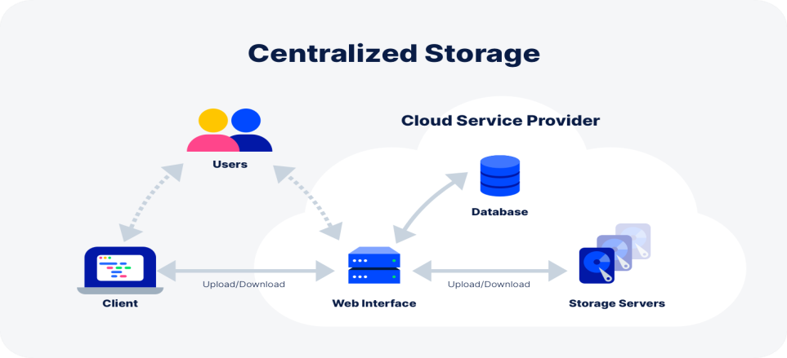

*Figure 1: Centralized Storage System in Cloud Environment.*

### 1.1 Background on Cloud Computing and its Limitations in Data Security

Cloud computing represents a model for providing a range of computing services, including storage, processing capabilities, and software applications, through the internet. Instead of depending on local servers or individual devices for these functions, individuals can access and utilize computing resources hosted by the distant data centers. This approach offers numerous benefits such as cost-effectiveness, scalability, and easy access. Nevertheless, it presents certain drawbacks, particularly in terms of data security [1]. The progression of cloud computing has been notable.

Cloud computing has emerged as a groundbreaking paradigm in the field of information technology, fundamentally altering the conventional methods of storing, processing, and handling data. This innovative model allows individuals to utilize a collective pool of computing resources, comprising servers, storage, and applications, via the internet. The transition from on-site infrastructure to cloud-based solutions has markedly enhanced scalability, adaptability, and cost-effectiveness for businesses spanning diverse sectors.

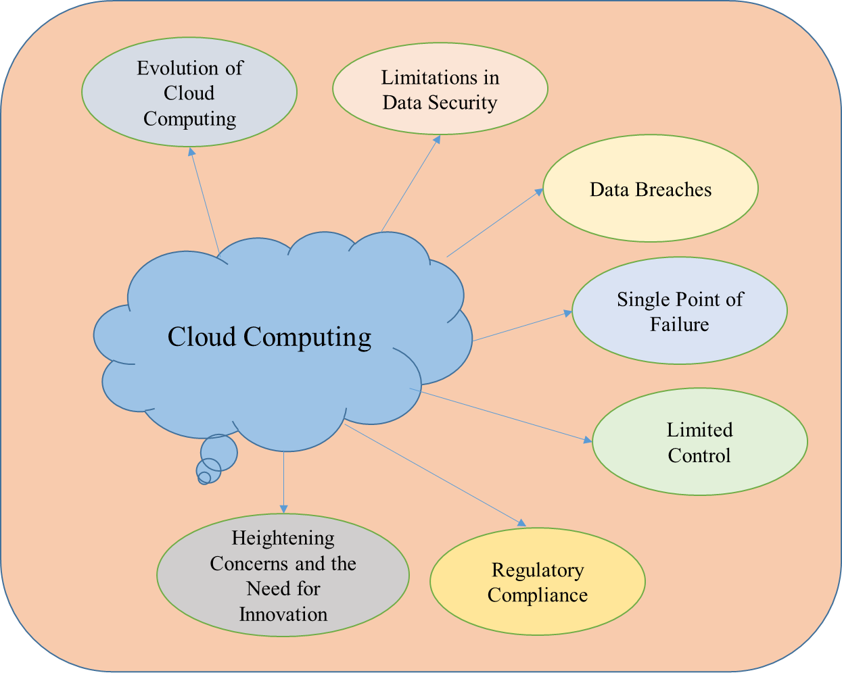

*Figure 2: Cloud Computing Limitations in Data Security.*

###### Limitations in Data Security

Although the utilization of cloud computing offers numerous benefits, it also presents challenges, particularly concerning data security. The centralized structure of cloud storage, where data resides on offsite servers managed by third-party vendors, poses inherent risks. Companies rely on external providers to safeguard their sensitive and vital data, prompting apprehensions regarding the privacy, authenticity, and accessibility of their information.

###### Data Breaches

Centralized cloud storage becomes a primary focus for malicious individuals aiming to gain unauthorized entry to sensitive data. Incidents of data breaches have become increasingly common, posing risks to individuals' privacy and compromising businesses' proprietary information.

###### Single Point of Failure

The aggregation of data in one place creates a potential single point of failure. Any security lapse or breach within the cloud infrastructure can lead to significant and far-reaching consequences for the entities involved.

###### Limited Control

Users relinquish a degree of control over their data when utilizing cloud services. Dependencies on service providers for security measures may lead to uncertainties about the adequacy of these measures.

###### Regulatory Compliance

Organizations operating in regulated industries face challenges in ensuring that their use of cloud services aligns with industry-specific compliance requirements. This includes concerns related to data residency, privacy laws, and industry regulations.

###### Heightening Concerns and the Need for Innovation

The increasing occurrence and complexity of cyber threats emphasize the crucial need to strengthen data security measures in cloud computing. As more organizations transition their activities to the cloud, it becomes essential to recognize and address the challenges in data security. This context drives the exploration of novel solutions like blockchain technology, which inherently tackles certain vulnerabilities linked with centralized cloud storage.

#### 1.1.1 Benefits of Cloud Storage

The widespread integration of cloud storage has become common across various sectors, propelled by numerous advantages that address the changing requirements of both enterprises and individuals. Grasping the advantages of cloud storage is essential for framing the larger context in which the challenges and prospects of secure data sharing in the cloud are positioned.

Scalability and Flexibility

An essential benefit of cloud storage is its innate scalability. Providers of cloud services furnish adaptable storage options, enabling companies to adjust their storage capacities according to fluctuations in demand. This flexibility guarantees that businesses can accommodate varying data volumes and changing storage needs without necessitating significant investments in infrastructure.

Cost-Efficiency

Cloud storage obviates the need for organizations to invest in and manage extensive physical infrastructure. This transition from a capital-intensive model to a pay-as-you-go operational model leads to substantial cost reductions. The capability to pay solely for the resources consumed enables organizations to allocate their budgets more effectively.

Accessibility and Remote Collaboration

Cloud storage enables universal access to data, allowing users to access, upload, or edit files from any location with internet access. This accessibility is especially beneficial in an age where remote work and collaboration are fundamental aspects of contemporary business practices. Team members situated in different locations can collaborate effortlessly on shared documents in real-time.

Automated Backups and Disaster Recovery

Cloud storage providers usually employ strong backup and disaster recovery systems. Automated backups ensure regular duplication of data, decreasing the chances of data loss caused by hardware failures or unexpected incidents. If a disaster occurs, organizations can quickly restore their data, minimizing downtime and potential disruptions to business activities.

Enhanced Security Measures

Cloud storage providers allocate significant resources to security infrastructure, often exceeding the capabilities of individual organizations. They implement advanced encryption protocols, multi-factor authentication, and continuous monitoring to create a secure environment for storing sensitive data. This collaborative approach to security enables businesses to leverage state-of-the-art protective measures.

Streamlined Collaboration Through File Sharing

Cloud storage platforms provide effortless file-sharing features, improving collaboration within organizations. Users can share files or folders with designated permissions, streamlining collaborative work without relying on complex email exchanges or physical file transfers. This streamlined collaboration promotes efficiency and flexibility in project workflows.

Centralized Data Management

Cloud storage centralizes data management, providing a unified repository for diverse types of information. This centralization simplifies data governance, making it easier for organizations to implement consistent policies, ensure compliance with regulatory frameworks, and manage data throughout its

lifecycle.

Continuous Innovation and Updates

Cloud storage solutions are dynamic and subject to continuous updates and innovations by service providers. This ensures that organizations leveraging cloud storage benefit from the latest technological advancements, security enhancements, and performance optimizations

#### 1.1.2 Security Concerns and Limitations of Cloud Environments

While the integration of cloud environments offers numerous advantages, it's crucial to thoroughly evaluate the security risks and limitations [2] that come with it. Recognizing these challenges is fundamental for laying a strong groundwork for the further examination of blockchain technology as a potential remedy for secure data sharing within cloud systems.

Data Privacy and Compliance

One of the primary issues regarding security in cloud environments pertains to data privacy and adherence to regulations. When organizations store sensitive data with cloud service providers, there's uncertainty about who has control over and ownership of the data. Meeting the requirements of various regulatory standards becomes challenging, especially when data is transmitted across different jurisdictions.

Cybersecurity Threats and Incidents

Cloud environments face a range of cybersecurity risks, such as data breaches, unauthorized entry, and malware infiltration. The shared responsibility model between cloud providers and users requires a clear understanding of security duties. Neglecting to establish strong security protocols can lead to compromised data integrity and confidentiality.

Identity and Access Management (IAM) Challenges

Ensuring robust identity and access management is essential for maintaining data security in cloud environments. Unauthorized access, misconfigured permissions, or compromised user credentials can result in data exposure. Addressing IAM challenges highlights the importance of comprehensive strategies covering user authentication, authorization, and auditing.

Data Encryption and Transit Security

Ensuring the security of data, whether at rest or in transit or crucial for preserving confidentiality. In cloud environments, it's essential to implement rigorous encryption protocols to protect data from interception during storage and transmission. Insufficient encryption measures pose a substantial risk, particularly given the volume of data transmitted across cloud networks.

Vendor Lock-In and Interoperability

Relying on a particular cloud service provider entails the risk of vendor lock-in. Moving data across different cloud platforms might present difficulties due to compatibility issues, potentially constraining an organization's flexibility in adapting to evolving business needs. It becomes essential to strategize for data portability and mitigate dependencies on specific vendors.

Limited Visibility and Control

Cloud environments frequently involve a balance between delegating infrastructure management and retaining detailed control. The lack of complete visibility into the underlying infrastructure may impede organizations from effectively monitoring and addressing security incidents. Achieving the appropriate equilibrium between delegating authority and maintaining oversight remains an on-going challenge.

DDoS Attacks and Service Disruptions

Cloud services face the risk of Distributed Denial of Service (DDoS) assaults, which can disrupt service availability by inundating cloud resources, making services unreachable for legitimate users. Combating DDoS assaults necessitates cooperative actions between cloud providers and users to deploy effective countermeasures.

Continuous Monitoring and Auditing

Developing a robust continuous monitoring and auditing system is vital for promptly detecting and resolving security incidents. Insufficient monitoring could lead to delayed identification of suspicious behaviour, potentially escalating security breaches. Implementing proactive measures for on-going security assessment is essential for maintaining a strong security posture and alleviating the responsibility of internally managing these updates.

### 1.2 Introduction to Blockchain Technology

###### Background

Originally introduced as the foundational architecture for the cryptocurrency Bitcoin, blockchain technology has undergone significant evolution, emerging as a versatile and transformative solution applicable across diverse sectors. Essentially, a blockchain functions as a decentralized and distributed ledger, ensuring secure, transparent, and immutable recording of transactions. Acquiring a fundamental understanding of blockchain principles is imperative for assessing its potential in enhancing secure data sharing within cloud environments.

###### How Blockchain Works

Blockchain operates as a series of blocks, with each block comprising a collection of transactions. This process entails.

###### Consensus Mechanism

Nodes within the network authenticate the transactions using a consensus mechanism. Popular mechanisms include Proof of Work (PoW) or Proof of Stake (PoS), guaranteeing consensus on the legitimacy of transactions.

###### Block Addition

Authenticated transactions are appended to a block, with each block referencing the preceding one via a cryptographic hash, creating a continuous chain.

###### Decentralized Validation

Transactions are independently verified by multiple nodes, enhancing security and trust. Consensus is reached through majority agreement.

###### Relevance to Data Security

The integration of blockchain technology holds significant relevance in mitigating the security obstacles encountered in cloud environments. Through its utilization of decentralization, immutability, and transparency, blockchain offers a resilient infrastructure for ensuring secure and auditable data sharing.

###### Blockchain Beyond Cryptocurrencies

Although blockchain initially gained traction within the realm of cryptocurrencies, its utility transcends this original purpose. Various industries, including finance, healthcare, supply chain, and now cloud computing, have acknowledged blockchain's capacity to transform data handling, security, and transparency.

#### 1.2.1 Core Features of Blockchain (Decentralization, Immutability, Transparency)

Blockchain, the underlying technology powering cryptocurrencies such as Bitcoin, presents a spectrum of revolutionary attributes that stretch beyond the domain of digital money. Grasping these fundamental characteristics is imperative for fully leveraging the capabilities of blockchain technology**.**

Decentralization

The concept of decentralization serves as a fundamental aspect of blockchain technology, revolutionizing conventional models of centralized authority. Within a decentralized blockchain network, power is dispersed among numerous nodes, removing the necessity for a central governing body. This decentralized structure not only strengthens the system's resilience but also reduces the vulnerabilities linked to a singular point of failure. Decentralization cultivates a trust less ecosystem wherein users can conduct transactions independently, devoid of intermediaries, thereby fostering autonomy and security.

Immutability

Immutability represents a crucial attribute ensuring the integrity and enduring nature of data stored on the blockchain. The moment a block joins the chain; its contents become practically invulnerable to tampering. This immutability is realized through cryptographic hash functions that generate distinct identifiers for every block and incorporate references to the preceding block. Any endeavour to modify data within a block necessitates altering subsequent blocks, a task computationally impractical to achieve. Immutability establishes a dependable and unchangeable ledger of transactions, essential for upholding the integrity of data exchanged within the blockchain.

Transparency

Transparency is ingrained within the framework of blockchain, presenting an inclusive and visible account of all transactions to each participant within the network. Each node in the blockchain network retains a replica of the complete transaction log, guaranteeing that data is observable and confirmable by all involved parties. This transparency not only fosters trust among participants but also establishes a means for examination and answerability. In the context of secure data exchange in cloud environments, transparency emerges as a potent instrument to verify and have faith in shared data among authorized entities, eliminating the necessity for centralized intermediaries.

Synergy of Core Features

These core features of decentralization, immutability, and transparency work synergistically to create a robust and secure foundation for blockchain technology. Decentralization addresses concerns of centralized control and susceptibility to single points of failure, immutability guarantees the permanence of recorded data, and transparency ensures that all participants have an unobstructed view of the shared information.

Application to Data Security

In the context of ensuring data security in cloud environments, incorporating these fundamental attributes becomes essential. Decentralization reduces the risk associated with a central server, immutability prevents unauthorized changes, and transparency fosters trust in the shared data. Grasping and utilizing these characteristics are pivotal in leveraging the potential of blockchain to enhance secure data sharing in cloud environments.

#### 1.2.2 Brief Overview of Blockchain Technology

Blockchain technology marks a significant departure in data storage, sharing, and protection methodologies. Essentially, it functions as a decentralized and distributed ledger, ensuring transparent, secure, and tamper-proof record-keeping. To understand its importance in bolstering data security within cloud environments, let's explore a concise summary of its primary components and operations.

Structure of a Blockchain

A blockchain comprises a series of blocks, with each structure of blockchain [3] containing a collection of transactions. These blocks are interconnected using cryptographic hashes, forming an unbroken and unchangeable chain. Transactions undergo validation and inclusion in the blockchain through a consensus mechanism, guaranteeing consensus among network members regarding the legitimacy of these

transactions.

Decentralization in Action

Decentralization serves as a fundamental principle that sets blockchain apart from conventional decentralized [4] systems. Within a blockchain network, no single entity holds control or ownership over the entire network. Instead, authority is distributed across multiple nodes, which are individual computers engaged in the network. This decentralized structure bolsters security by removing central vulnerabilities and mitigating the likelihood of malicious attacks.

Immutability Ensures Data Integrity

Immutability is established using cryptographic hash functions, which generate unique identifiers for each block and incorporate references to the preceding block. Once a block joins the chain, any attempt to modify its contents necessitates altering subsequent blocks, which is computationally impractical. This immutability guarantees the integrity and lasting nature of stored data, which is crucial for secure data exchange.

Transparency Fosters Trust

Transparency is a core characteristic that distinguishes blockchain technology. All network participants have access to the complete transaction history, forming an open and auditable ledger. This transparency fosters trust among users and establishes accountability, which are essential components for ensuring secure data sharing in any setting.

Beyond Cryptocurrencies

Although blockchain initially gained recognition through cryptocurrencies, its utility spans across various sectors beyond finance, including healthcare and now cloud computing. These industries acknowledge the significant potential of blockchain in revolutionizing data management by providing security, transparency, and decentralization.

Practical Implications for Cloud Security

In the scenario of ensuring secure data sharing in cloud environments, the attributes of decentralization, immutability, and transparency provided by blockchain are immensely valuable. Through its provision of a secure and tamper-resistant ledger, blockchain technology tackles the inherent weaknesses of centralized cloud storage, presenting a hopeful resolution for data security issues.

### 1.3 Problem Statement: Need for Secure Data Sharing in Cloud Environments

In today's cloud computing environment, the need for effortless data sharing is widespread. Yet, this ease of sharing brings along increasing worries about data security. There's a pressing need to implement strong security measures due to the growing risks of data breaches, integrity violations, and the intricate access control issues inherent in shared cloud environments. This segment discusses the essential requirement for secure data sharing and highlights the challenges that emphasize the necessity for innovative solutions such as blockchain technology. Following sections will delve deeper into these challenges and suggest a framework to bolster data sharing security in cloud settings.

##### Unravelling the Dilemma

The emergence of cloud computing has certainly transformed data management and processing practices within organizations. Yet, amidst this digital revolution, there are notable challenges, with data security standing out as one of the most crucial. As businesses progressively transition their activities to the cloud, there's a growing urgency to implement strong measures to guarantee the secure exchange of data within these environments.

##### Centralized Cloud Storage Dilemma

While centralized cloud storage provides convenience and scalability, it also brings significant concerns regarding data breaches and unauthorized entry. Placing sensitive data in a centralized server creates a single vulnerability point. Cyber threats, ranging from advanced attacks to insider risks, present immediate dangers to the confidentiality and integrity of shared data. The consequences of a security breach extend beyond financial losses, including harm to reputation, legal consequences, and disruptions to business operations.

##### The Imperative of Secure Data Sharing

In the interconnected landscape of contemporary business operations, data sharing is indispensable. Collaborative efforts, seamless workflows, and real-time decision-making rely on the swift and secure exchange of information. This necessity becomes particularly pronounced in multi-cloud or hybrid cloud environments where data traverses diverse platforms. Therefore, the need for secure data sharing is not merely a preference but a strategic imperative for organizations navigating the digital terrain.

##### Inadequacies of Traditional Approaches

Conventional methods of data security, typically reliant on perimeter-based defense, face challenges in adjusting to the dynamic and dispersed structure of cloud environments. While firewalls and access controls are crucial, they may not fully address the intricacies of data sharing across varied cloud infrastructures. Moreover, solely relying on cloud service providers for security may result in reduced control and increased reliance on third-party entities.

##### Balancing Security and Accessibility

Striking the right balance between security and accessibility presents a distinct challenge. Organizations aim to facilitate seamless access to shared data for authorized users while enhancing defense against unauthorized access attempts. The challenge lies in promoting collaboration without jeopardizing the confidentiality and integrity of sensitive data.

##### Addressing the Complexity of Cloud Environments

Cloud environments, known for their dynamic characteristics and varied service models, add complexity to the security realm. With the adoption of Infrastructure as a Service (IaaS), Platform as a Service (PaaS), and Software as a Service (SaaS) models, it becomes crucial to develop a cohesive and flexible security framework.

### 1.4 Project Objectives

###### Navigating the Blockchain Landscape

The objectives outlined in this project serve as the guiding compass in the exploration of leveraging Blockchain Technology for Secure Data Sharing in Cloud Environments. Each objective has been meticulously crafted to address specific facets of the research landscape [5], aiming to contribute meaningful insights to the discourse surrounding blockchain and its strategic implications for enhancing data security in cloud computing.

#### 1.4.1 Analyze the Potential of Blockchain for Secure Data Sharing

The primary aim of this project is to conduct a thorough investigation into how blockchain technology could enhance secure data sharing in cloud environments. Blockchain's reputation for being decentralized, immutable, and transparent makes it an appealing option for tackling the security issues often associated with centralized cloud storage. This section lays the groundwork for a comprehensive exploration of blockchain's potential to transform data sharing, offering insights into its advantages, challenges, and potential impact on improving data security in the cloud**.**

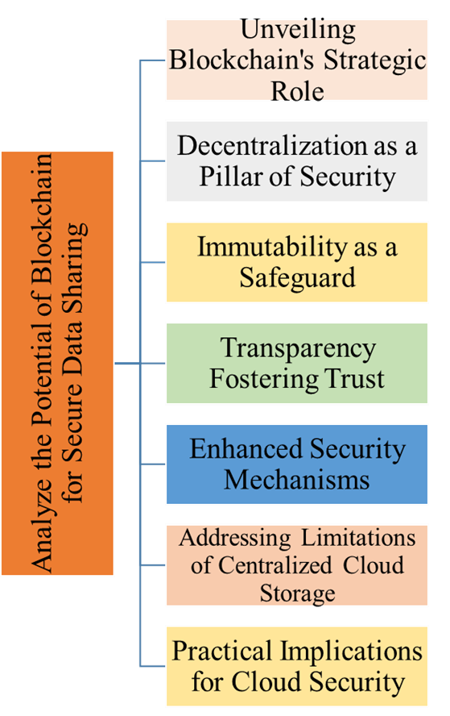

*Figure 3: Analyse the Potential of Blockchain for Secure Data Sharing.*

Unveiling Blockchain's Strategic Role

The core objective of this project component is to undertake a meticulous analysis of the transformative potential embedded within blockchain technology concerning the imperative of secure data sharing within cloud environments in strategic role [6]. This exploration seeks to unravel how blockchain's unique attributes can serve as a robust foundation for addressing the multifaceted challenges associated with centralized cloud storage.

Decentralization as a Pillar of Security

The cornerstone of this examination revolves around the fundamental concept of decentralization ingrained in blockchain technology. Through the distribution of data across a network of nodes instead of depending on a central server, blockchain inherently reduces the vulnerabilities linked with single points of failure. Decentralization not only bolsters data resilience but also introduces a significant departure from conventional ideas of data ownership and control.

Immutability as a Safeguard

Another essential aspect under examination is the notion of immutability within blockchain. Once information is registered on the blockchain, it becomes exceedingly difficult, if not impossible, to modify or tamper with historical records. This immutability not only guarantees the integrity of the shared data but also creates a transparent and traceable pathway, which is vital for auditability and accountability.

Transparency Fostering Trust

The emphasis on transparency in blockchain is a crucial aspect of this examination. The decentralized and openly accessible ledger feature of blockchain guarantees that all authorized participants within a network can observe the shared data. This transparency not only cultivates trust among stakeholders but also conforms to the modern need for transparency and accountability in data management procedures.

Enhanced Security Mechanisms

Analysing the potential of blockchain also entails delving into the enhanced security mechanisms [7] embedded in its architecture. From cryptographic hashing to consensus algorithms, blockchain introduces layers of security that fortify data shared within cloud environments. The cryptographic nature of transactions ensures confidentiality, while consensus algorithms validate the authenticity of transactions, contributing to a secure data-sharing ecosystem.

Addressing Limitations of Centralized Cloud Storage

The analysis will systematically dissect how blockchain's potential addresses the limitations of centralized cloud storage, particularly concerning data breaches and unauthorized access. By providing an alternative paradigm, blockchain offers a potential remedy to the vulnerabilities associated with relying solely on centralized entities for data storage and management.

Practical Implications for Cloud Security

Ultimately, this analysis transcends theoretical exploration to uncover the practical implications of integrating blockchain into cloud environments [8] for secure data sharing. It paves the way for a strategic understanding of how blockchain, with its unique combination of decentralization, immutability, and transparency, can reshape the landscape of data security within the dynamic realm of cloud computing.

#### 1.4.2 Evaluate the Feasibility of Implementing a Blockchain-Based Solution

In this section, the project embarks on a critical examination the practical assessment of deploying a blockchain-driven approach to ensure secure data sharing within cloud environments. This evaluation seeks to connect the theoretical ideals of blockchain with the pragmatic factors and obstacles that organizations might face when embracing such an innovative technology.

Technical Considerations

The evaluation begins with a meticulous examination of the technical feasibility of incorporating a blockchain-based solution. This involves an in-depth analysis of the existing technology infrastructure within cloud environments, scrutinizing the compatibility, scalability, and interoperability of blockchain with established systems. Special attention is given to understanding how blockchain aligns with prevalent cloud architectures and whether it introduces any disruptive elements that necessitate adaptation.

Scalability and Performance Metrics

A central focus of this evaluation is scalability, considering the potential deployment across diverse cloud ecosystems. Scalability metrics [9], including transaction throughput and network efficiency, are scrutinized to ensure that a blockchain solution can accommodate the dynamic and often resource-intensive nature of data sharing within cloud environments. Potential bottlenecks and performance limitations are identified to provide a realistic assessment of scalability.

Regulatory and Compliance Landscape

The feasibility assessment expands its scope beyond technical considerations to include an examination of the regulatory and compliance environment. It scrutinizes adherence to data protection regulations, industry norms, and regional legislations. The objective is to offer a thorough insight into how blockchain technology aligns with or presents hurdles to prevailing compliance structures, ensuring that the suggested approach complies with legal mandates.

Integration Challenges

Given the intricate nature of cloud environments, integration challenges [10] are scrutinized closely. The project assesses how seamlessly a blockchain-based solution can be integrated into existing cloud infrastructures, minimizing disruptions and ensuring a smooth transition. Attention is given to potential friction points, such as data migration, system downtime, and the learning curve for existing personnel.

Cost-Benefit Analysis

Assessing feasibility also entails conducting an extensive cost-benefit evaluation [11]. This involves analysing the initial investment necessary for implementing blockchain technology, on-going maintenance expenses, and the potential return on investment in terms of improved data security. The project seeks to offer stakeholders a transparent view of the financial considerations linked to the integration of a blockchain-driven solution.

Identifying Implementation Challenges

To offer a holistic view, the evaluation identifies potential implementation challenges [12] that organizations might encounter. This includes factors such as the need for skilled personnel, potential resistance to change, and the time required for system integration. Recognizing these challenges ensures that stakeholders are well-informed and can proactively address hurdles during the implementation phase.

# Chapter 2. Literature Review

**Navigating the Landscape of Blockchain in Cloud Data Security**

The literature review segment of this document provides an extensive investigation into the existing corpus of knowledge concerning the convergence of blockchain technology and secure data sharing within cloud environments. By thoroughly analysing academic papers, research studies, and industry insights, this review seeks to amalgamate the present understanding, pinpoint significant trends, and highlight areas requiring further exploration, thus propelling the proposed research endeavours.

### 2.1 Existing Research on Blockchain-based Secure Data Sharing

The investigation into the overlap between blockchain technology and secure data sharing within cloud environments commences with a thorough examination of prior research. Seminal discoveries from initial investigations established the foundation for comprehending the revolutionary capacity of blockchain in augmenting data security. These fundamental studies elucidate the fundamental principles and mechanisms that underpin secure data exchange within decentralized structures.

##### Unpacking Decentralized Consensus Mechanisms

A significant area of interest in the current research terrain centers on decentralized consensus mechanisms. Investigations delve into the complexities of consensus algorithms like Proof of Work (PoW), Proof of Stake (PoS), and Practical Byzantine Fault Tolerance (PBFT). These mechanisms not only guarantee the integrity of shared data but also establish a sturdy basis for secure and tamper-resistant transactions within cloud environments.

##### Cryptographic Techniques for Enhanced Security

Existing literature underscores the pivotal role of cryptographic techniques in fortifying data security. Encryption methodologies, including public-key cryptography and homomorphic encryption, emerge as critical components in securing sensitive information during storage and transmission. The review critically assesses the effectiveness of these cryptographic measures in mitigating potential vulnerabilities and ensuring confidentiality in cloud-based data sharing.

##### Smart Contracts as Enablers of Secure Data Sharing

A notable advancement in secure data sharing using blockchain stems from the incorporation of smart contracts. Studies have investigated how self-executing contracts can automate and enforce agreements for secure data sharing. Through the integration of programmable logic within the blockchain, smart contracts enable trust less collaboration, ensuring that data access and sharing comply with pre-established rules without requiring centralized intermediaries.

##### Case Studies across Diverse Industries

The literature review encompasses a range of case studies that highlight the practical applications of blockchain in securing data sharing across different sectors. Examples from healthcare, finance, supply chain, and other industries offer valuable insights into the tangible outcomes of employing blockchain technology. These case studies provide a nuanced perspective on the specific challenges and customized solutions, contributing to a comprehensive understanding of blockchain's effectiveness in diverse fields.

##### Evaluating the Evolution of Consent Mechanisms

As blockchain matures as a technology, research has scrutinized the evolution of consent mechanisms [13] governing data sharing. This includes advancements in user-centric control, enabling individuals to exercise granular control over their shared data. The review critically assesses how evolving consent mechanisms contribute to the establishment of user-centric, privacy-preserving ecosystems within cloudbased data sharing frameworks.

##### Challenges and Lessons Learned

A comprehensive literature review not only highlights successes but also addresses challenges and lessons learned from prior research. Unanticipated roadblocks, scalability issues, and potential security pitfalls are critically examined. By acknowledging the hurdles encountered in earlier studies, the documentation aims to inform the proposed framework with a pragmatic understanding of the intricacies involved in implementing blockchain-based secure data sharing solutions.

#### 2.1.1 Review of Relevant Academic Papers and Industry Reports

In this subsection, we delve into a meticulous review of relevant academic papers and industry reports that constitute the backbone of contemporary insights into blockchain-based secure data sharing. This comprehensive survey aims to distil key findings, methodologies, and breakthroughs documented by scholars and landscape [14], laying the groundwork for a nuanced understanding of the subject matter.

###### Academic Rigor and Scholarly Contributions

The literature review encompasses a scrutiny of academic papers that exemplify rigor in research methodology and contribute novel insights to the discourse. By examining peer-reviewed publications, we gain access to the latest advancements in blockchain technology applied to secure data sharing. These scholarly contributions serve as pillars upon which the proposed research builds, ensuring a solid theoretical foundation.

###### Industry Reports: Bridging Theory and Practice

Alongside academic papers, the documentation examines industry reports the bridge theory with practice. These reports provide insights from real-world applications, highlighting challenges organizations encounter and the strategies used to integrate blockchain into data sharing environments. By merging academic theory with industry insights, this section enhances the overall understanding of the topic.

###### Emerging Trends and Innovations

The review extends beyond foundational works to encompass emerging trends and innovative approaches documented in recent academic papers and industry reports. By identifying cutting-edge research, the documentation aims to not only present the current state of affairs but also anticipate future trajectories. This forward-looking perspective ensures that the proposed research remains attuned to the dynamic nature of blockchain technology and its evolving role in secure data sharing.

###### Methodological Insights and Best Practices

Through a careful analysis of academic papers and industry reports, this subsection extracts methodological insights and best practices employed in the field. It explores how researchers and industry professionals approach the challenges of designing, implementing, and evaluating blockchain-based secure data sharing solutions. By distilling methodological approaches, the documentation aims to inform the proposed framework with lessons learned from prior endeavours.

###### Addressing Limitations and Gaps

An inherent aspect of reviewing relevant literature is the identification of limitations and gaps in existing research. This critical examination acknowledges areas where academic and industry efforts may fall short or leave questions unanswered. By recognizing these gaps, the documentation positions the proposed research as an opportunity to contribute meaningful solutions to unresolved challenges within the realm of blockchain-based secure data sharing.

###### Synthesis and Integration

The culmination of this subsection involves the synthesis [15] and integration of findings from academic papers and industry reports. By synthesizing diverse perspectives, the documentation aims to present a cohesive narrative that not only encapsulates the current state of knowledge but also identifies areas of convergence and divergence within the literature. This synthesis sets the stage for the subsequent sections of the documentation, offering a comprehensive understanding of the multifaceted landscape of blockchain-based secure data sharing.

#### 2.1.2 Identification of Key Research Trends and Findings

###### Unveiling the Landscape of Key Research Trends

Within this subsection, we embark on a comprehensive exploration to identify and elucidate the key research trends and findings that have emerged from the collective body of academic papers and industry reports. The objective is to distil overarching patterns, recurring themes, and seminal discoveries that signify the trajectory of research in blockchain-based secure data sharing.

###### Evolution of Blockchain Applications

One discernible trend that emerges from the reviewed literature is the dynamic evolution of blockchain applications. Initially conceptualized as a decentralized ledger for cryptocurrencies, blockchain has transcended its origins and found profound applications in secure data sharing. The documentation traces the metamorphosis of blockchain from a niche technology to a versatile tool with far-reaching implications for data security within cloud environments.

###### Integration of Privacy-Preserving Mechanisms

As the literature unfolds, a pronounced trend centers around the integration of privacy-preserving mechanisms [16] within blockchain frameworks. Researchers and industry practitioners recognize the importance of safeguarding sensitive information, prompting an exploration of cryptographic techniques and consensus models that enhance privacy in data sharing. The documentation delves into the nuances of these mechanisms and their implications for fostering secure and confidential data exchange.

###### Interdisciplinary Collaborations and Cross-Industry Insights

An interdisciplinary approach emerges as a prevalent trend, with researchers from diverse fields converging to contribute to the discourse on secure data sharing. The literature review showcases collaborations between blockchain experts, data scientists, legal scholars, and industry professionals. This cross-pollination of ideas results in comprehensive insights that not only address technological challenges but also consider legal, ethical, and regulatory dimensions. The documentation highlights the significance of these collaborative efforts in shaping a holistic understanding of blockchain's role in securing data within cloud environments.

###### Scalability Solutions for Mass Adoption

Scalability remains a persistent challenge in blockchain technology, and the literature reflects a concerted effort to devise solutions for mass adoption. Key trends revolve around novel consensus algorithms, layer-two scaling solutions, and advancements in distributed ledger technologies. The documentation critically examines these trends, emphasizing their impact on overcoming scalability barriers and facilitating widespread adoption of blockchain-based secure data sharing.

###### User-Centric Approaches and Governance Models

A noteworthy trend centers on the prioritization of user-centric approaches and governance models. Recognizing the importance of user control over shared data, researchers explore decentralized identity solutions, self-sovereign identity frameworks, and participatory governance structures. This user-centric paradigm shift is integral to addressing concerns related to data ownership and autonomy within blockchain-based ecosystems.

###### Challenges and Mitigation Strategies

An undercurrent within the identified trends pertains to the acknowledgment of challenges and the proposition of mitigation strategies. The documentation synthesizes insights into the challenges posed by blockchain-based secure data sharing, including regulatory uncertainties, interoperability issues, and user adoption hurdles. By examining proposed mitigation strategies, the documentation equips itself with a practical understanding of how researchers and industry stakeholders navigate impediments to the seamless integration of blockchain in secure data sharing environments.

### 2.2 Applications of Blockchain in Secure Data Sharing (Examples)

##### Unveiling Practical Implementations and Use Cases

These concrete examples illustrate how blockchain technology has been utilized to meet the need for secure data sharing within cloud environments. By analysing these cases, we acquire insights into the various scenarios where blockchain has emerged as a powerful tool in augmenting data security.

##### Healthcare Data Interoperability through Blockchain

One prominent application lies within the realm of healthcare, where the interoperability of patient data is paramount. Blockchain's decentralized architecture facilitates secure and seamless sharing of medical records across disparate healthcare providers. Real-world examples, such as initiatives using blockchain to create a unified patient record accessible to authorized entities, are scrutinized. The documentation elucidates the mechanisms employed to ensure data integrity, patient consent management, and the prevention of unauthorized access.

##### Financial Data Transparency and Smart Contracts

Blockchain technology finds applications in the financial sector, especially in situations requiring secure data sharing for intricate financial transactions. Smart contracts, which are self-executing contracts with predefined business logic stored on the blockchain, play a crucial role in ensuring transparent and tamper-resistant sharing of financial data. Detailed analyses of real-world cases where blockchain has been applied in trade finance, cross-border payments, and auditing procedures are provided. The document investigates how blockchain's immutability and transparency attributes enhance data integrity and trust within financial data sharing environments.

##### Decentralized Identity Management for Enhanced Security

The role of Blockchain’s is a decentralized identity [17] of management to explore as an example of secure data sharing applications. By shifting from centralized identity repositories to blockchain-based decentralized identity solutions, individuals gain more control over their personal information. Real-world cases, where blockchain is utilized to establish self-sovereign identity and streamline identity verification processes, are scrutinized. The documentation elucidates how blockchain's decentralized nature mitigates risks associated with centralized identity systems, enhancing security in data sharing practices.

##### Supply Chain Transparency and Traceability

In the supply chain industry, blockchain technology is utilized to enhance transparency and traceability in data sharing processes. By leveraging blockchain's capability to establish an unchangeable and transparent record, efforts are made to track the origin of products, authenticate their authenticity, and optimize supply chain operations. Real-world instances, such as blockchain applications in food traceability and verifying the authenticity of luxury goods, are meticulously investigated. The documentation illuminates how blockchain reinforces data integrity and trust within intricate supply chain networks.

##### Academic Credential Verification through Blockchain

Blockchain technology is being applied in the field of education, specifically concerning secure data sharing concerning academic credentials. We examine cases where blockchain is deployed to generate academic records that are tamper-proof and easily verifiable. The documentation delves into how blockchain safeguards the authenticity of academic credentials, reduces fraudulent practices, and offers a dependable means for employers and educational institutions to authenticate qualifications.

##### Real Estate Transactions and Smart Contracts

In the real estate sector, blockchain's role in secure data sharing is demonstrated by its utilization of smart contracts in property transactions. We investigate practical cases where blockchain enables transparent and secure property transactions, automates contract agreements, and maintains immutable records of ownership changes. The documentation explains how blockchain's decentralization and smart contract functionalities enhance data security and foster trust in real estate data sharing environments.

#### 2.2.1 Healthcare

Blockchain technology has become a transformative influence across various sectors, including healthcare. In healthcare, blockchain provides a decentralized and secure framework for handling and exchanging sensitive patient information. This innovative method guarantees the integrity and confidentiality of medical records, thereby minimizing the chances of unauthorized access or manipulation. An essential benefit of integrating blockchain in healthcare is the creation of a transparent and immutable ledger. This decentralized ledger ensures that every transaction or data entry is time stamped and connected to the preceding one, establishing a verifiable and unalterable chain. Such a feature enhances the trustworthiness of medical data, ultimately resulting in enhanced patient care and outcomes.

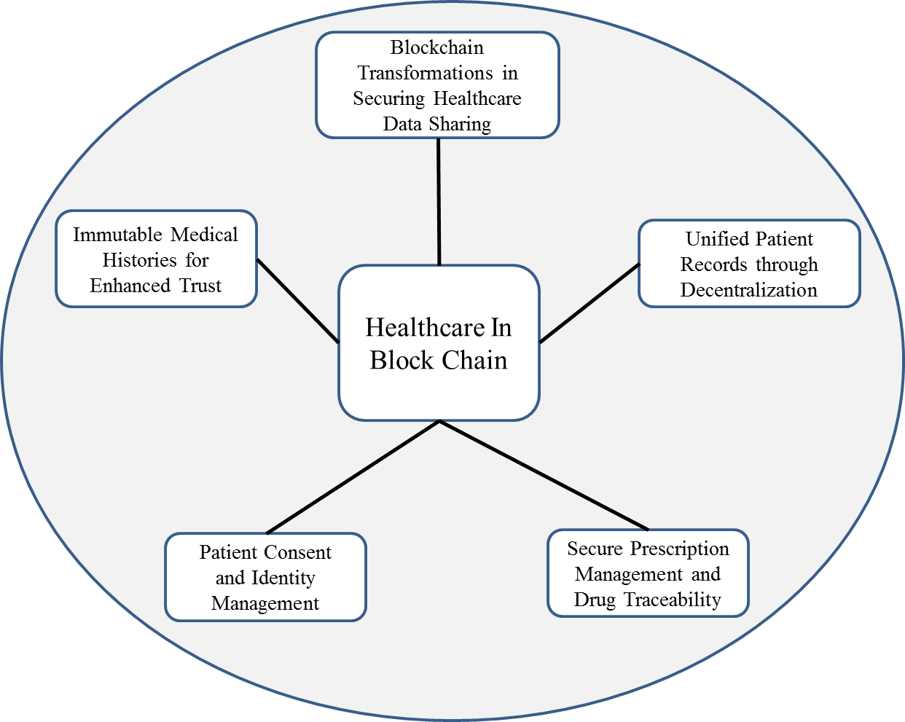

*Figure 4: Healthcare in block chain.*

###### Blockchain Transformations in Securing Healthcare Data Sharing

In the healthcare sector, the adoption of blockchain technology has surfaced as a pioneering remedy for the on-going hurdles linked with secure data exchange. This section explores the precise uses and revolutionary effects of blockchain within healthcare, where protecting confidential patient data holds utmost significance.

###### Unified Patient Records through Decentralization

A significant application of blockchain in healthcare pertains to establishing consolidated patient records. Conventional healthcare setups frequently struggle with fragmented patient information dispersed among various providers, impeding interoperability. Blockchain's decentralized structure tackles this issue by facilitating a unified and immutable patient record accessible to authorized parties. Instances of realworld deployment, such as pilot initiatives ensuring smooth data exchange among healthcare providers using blockchain, are examined. The document elaborates on the mechanisms utilized, including cryptographic hashing and smart contracts, to uphold data integrity and manage patient consent effectively.

###### Secure Prescription Management and Drug Traceability

Blockchain technology is instrumental in enhancing the security of prescription management and ensuring the traceability of pharmaceuticals throughout the supply chain. This subsection investigates instances where blockchain is employed to create transparent and immutable records of drug manufacturing, distribution, and prescription details. The documentation explores how blockchain's decentralized nature mitigates the risks of counterfeit drugs, reduces instances of fraud, and provides a robust system for tracking the provenance of pharmaceuticals.

###### Patient Consent and Identity Management

The function of blockchain in ensuring secure and transparent management of patient consent is analysed within the framework of healthcare data sharing. Real-world scenarios where blockchain empowers patients to control their health data, enabling them to grant or revoke access to specific information, are examined. Decentralized identity management, facilitated by blockchain, aids in mitigating the risks linked with centralized repositories of patient data. This section delves into how blockchain's cryptographic principles and smart contracts support secure and privacy-focused strategies for patient consent and identity management.

###### Immutable Medical Histories for Enhanced Trust

Blockchain's immutability characteristic is utilized to establish medical histories that are tamper-proof and unchangeable, promoting enhanced trust in healthcare data. Through the application of blockchain, healthcare providers can guarantee that patient records retain their original form and credibility indefinitely. Real-world instances where blockchain is employed to generate an indelible trail of medical histories are thoroughly analysed. This documentation illuminates how blockchain's resilience against tampering bolsters the integrity of medical data, laying a secure groundwork for data sharing endeavours within the healthcare domain.

#### 2.2.2 Finance

Blockchain technology is revolutionizing the financial sector by offering a secure and transparent platform for conducting transactions. Within finance, blockchain acts as a decentralized ledger, guaranteeing an immutable record of financial transactions. This advancement not only strengthens security and diminishes fraud risks but also accelerates transaction procedures. The decentralized structure of blockchain eradicates the necessity for intermediaries in financial dealings, resulting in faster settlements and decreased transaction expenses. Additionally, smart contracts, a key component of blockchain, automate and uphold contract terms, further simplifying financial operations.

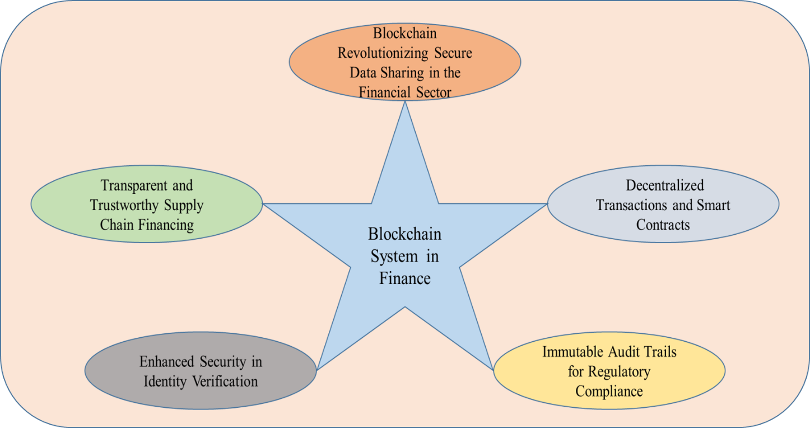

*Figure 5: Financing Blockchain System.*

###### Blockchain Revolutionizing Secure Data Sharing in the Financial Sector

In the financial industry, blockchain technology has become a game-changer, fundamentally altering conventional methods of secure data exchange. This section explores the various applications and fundamental shifts brought about by blockchain in managing financial data, highlighting its crucial role in boosting security and transparency.

###### Decentralized Transactions and Smart Contracts

The influence of blockchain on the financial industry is notably demonstrated by its capacity to enable decentralized transactions and simplify contractual procedures. This documentation examines cases where blockchain is utilized to establish transparent and automated financial transactions through smart contracts.

Real-world examples, including cross-border payments and decentralized financial applications based on blockchain, are investigated to elucidate how blockchain's decentralized structure eradicates the necessity for intermediaries, thereby ensuring swifter and more secure transactions.

###### Immutable Audit Trails for Regulatory Compliance

In the context of regulatory compliance, blockchain's immutability feature stands out as a gamechanger. This subsection investigates scenarios where blockchain is utilized to create immutable audit trails of financial transactions, enhancing transparency and accountability. The documentation explores how blockchain's resistance to tampering and chronological recording of transactions aids financial institutions in meeting regulatory requirements. Real-world applications, including blockchain-driven audits and compliance reporting, provide insights into the ways blockchain strengthens the financial industry's adherence to regulatory standards.

###### Enhanced Security in Identity Verification

Blockchain's application in enhancing security during identity verification [20] processes within the financial sector is closely examined. The documentation delves into real-world implementations where blockchain is leveraged to create decentralized and secure identity management systems. By employing cryptographic principles, blockchain ensures the integrity and privacy of customer identities, mitigating the risks associated with centralized databases. The exploration sheds light on how blockchain's decentralized identity verification contributes to a more secure and fraud-resistant financial ecosystem.

###### Transparent and Trustworthy Supply Chain Financing

The impact of blockchain on fostering transparent and reliable supply chain financing practices is examined in the financial sector. This documentation investigates scenarios where blockchain is employed to establish a decentralized and unchangeable ledger of transactions pertaining to supply chain financing. Real-world instances, such as the utilization of blockchain-powered supply chain finance platforms, demonstrate how blockchain's transparency and traceability aid financial institutions in mitigating risks linked to supply chain financing, such as fraud and discrepancies in transaction records.

### 2.3 Analysis of Strengths and Weaknesses of Existing Approaches

##### Understanding the Landscape: A Critical Assessment

In this segment, we undertake a comprehensive review of current methodologies for secure data sharing based on blockchain. The objective is to gain a detailed comprehension of the advantages and limitations associated with these methodologies, providing valuable insights for crafting a resilient framework that addresses the complexities of data sharing in cloud settings.

##### Strengths

* *Security Enhancement:* Present blockchain-driven methods demonstrate notable effectiveness in bolstering overall data security. The decentralized structure inherent in blockchain guarantees that once data is logged, it becomes impervious to unauthorized modifications or tampering. This resistance to tampering is a fundamental asset, fostering confidence in the reliability of shared data within cloud environments.
* *Transparency and Auditability:* One of the notable strengths lies in the transparency and auditability facilitated by blockchain. Each transaction or data interaction is recorded in an immutable ledger, providing a transparent trail of activities. This feature not only ensures accountability but also streamlines the auditing process, a crucial aspect in environments where multiple entities collaborate and share data.
* *Decentralization for Resilience:* Decentralization emerges as a strength, especially in ensuring resilience against single points of failure. Existing approaches leverage decentralized consensus mechanisms, contributing to the robustness of the overall system. This resilience is particularly valuable in cloud environments where reliability and continuous access to data are paramount.

##### Weaknesses

* *Scalability Challenges*: A common drawback in numerous current methodologies concerns scalability. As data and transaction volumes grow, the consensus mechanisms utilized in blockchain may face scalability issues. Maintaining a balance between decentralization and effective scalability continues to be a significant challenge, particularly in cloud environments where data demands can vary widely and rapidly.
* *Energy Consumption:* A significant drawback lies in the energy-intensive characteristics of specific consensus algorithms, such as Proof-of-Work. This aspect raises concerns, particularly in environments where energy efficiency is paramount. Assessing alternative consensus mechanisms that tackle energy consumption is vital for improving current approaches.
* *Integration Complexity:* Incorporating blockchain solutions into current cloud infrastructure can present challenges due to the complexity of aligning blockchain protocols with existing data storage and processing systems. Achieving smooth integration without causing disruptions to established workflows is a complex task that requires thorough consideration in the formulation of future frameworks.

##### Bridging the Gaps: Toward a Comprehensive Framework

The analysis of strengths and weaknesses provides a foundational understanding of the current landscape. Building upon these insights, the documentation moves forward to propose a potential framework for secure data sharing in cloud environments. This framework aims to leverage the strengths identified while addressing the weaknesses, offering a balanced and effective solution for the challenges posed by data sharing in the cloud.

#### 2.3.1 Comparison of Different Existing Solutions

###### Navigating the Landscape: A Comparative Analysis

The meticulous comparison of various existing solutions that harness blockchain technology for secure data sharing in cloud environments is discussed in this section. The objective is to discern the distinctive features, advantages, and drawbacks of each solution, laying the groundwork for informed decision-making and framework development.

###### Solution A: Decentralized Storage Platforms

**Advantages:**

* *Enhanced Data Control*: An evident advantage of decentralized storage platforms is their ability to empower users with greater control over their data. Utilizing blockchain technology, individuals can determine access rights and track data interactions with transparency.
* *Reduced Dependency:* These solutions often reduce dependency on centralized entities, fostering a more distributed and resilient data storage infrastructure.

**Drawbacks:**

* *Scalability Concerns:* Decentralized storage platforms may encounter the challenges in scaling efficiently as data volumes increase. Balancing decentralization with the ability to accommodate growing datasets remains an on-going challenge.

###### Solution B: Consortium Blockchains for Collaborative Data Sharing

**Advantages:**

* *Enhanced Privacy:* Consortium blockchains, which involve a specific group of entities working together to manage the network, stand out for their ability to offer improved privacy. This is especially beneficial for industries that prioritize strict data confidentiality standards.
* *Faster Consensus:* The smaller number of nodes in a consortium blockchain often leads to faster consensus mechanisms, promoting quicker transaction validation.

**Drawbacks:**

* *Limited Decentralization*: While offering more decentralization than traditional solutions, consortium blockchains are not fully decentralized. This compromise might impact resilience against certain types of attacks.

###### Solution C: Hybrid Approaches Incorporating Smart Contracts

**Advantages:**

* *Automated Governance:* Combining smart contracts into hybrid solutions presents an edge in terms of automated governance. These smart contracts allow for predefined rules regarding data access and sharing, thereby diminishing the necessity for manual intervention.
* *Flexibility:* The hybrid approach allows for flexibility in designing custom consensus mechanisms tailored to specific use cases.

**Drawbacks:**

* *Complexity in Implementation:* Implementing and managing smart contracts introduces a layer of complexity. Organizations may need skilled personnel for effective deployment and maintenance.
* Making Informed Choices: Implications for Future Frameworks
* By scrutinizing these existing solutions, we gain valuable insights into the diverse approaches adopted in the integration of blockchain technology for secure data sharing in cloud environments. The comparative analysis sets the stage for the subsequent sections, where we propose a potential framework that not only capitalizes on the strengths identified but also addresses the limitations, offering a balanced and effective solution for the challenges posed by data sharing in the cloud.

#### 2.3.2 Evaluation of Their Strengths and Weaknesses

###### Unveiling the Nuances: A Comprehensive Assessment

This section initiates a comprehensive assessment of the advantages and limitations in different existing solutions utilizing blockchain for secure data sharing within cloud environments. Grasping these subtleties is essential for determining the most suitable direction in crafting a resilient and efficient framework.

**Strengths Analysis**

###### Decentralized Storage Platforms

* *Enhanced Data Control:* The decentralized nature of storage platforms empowers users with unprecedented control over their data. Through cryptographic principles and distributed ledgers, data ownership and access privileges are securely managed.
* *Reduced Vulnerability:* By reducing dependency on centralized servers, these platforms inherently enhance data security, mitigating the risks associated with single points of failure.

###### Consortium Blockchains for Collaborative Data Sharing

* *Privacy Empowerment:* Consortium blockchains demonstrate exceptional capability in maintaining data privacy within a restricted circle. This proves especially advantageous in situations where safeguarding data confidentiality is of utmost importance, such as in healthcare or financial contexts.
* *Efficient Consensus:* The presence of a restricted number of participating entities within a consortium enables quicker consensus mechanisms, resulting in accelerated transaction validation.

###### Hybrid Approaches Incorporating Smart Contracts

* *Automated Governance:* Incorporating smart contracts introduces an automated governance layer, simplifying data access and sharing by implementing pre-established rules. This streamlining not only minimizes manual involvement but also boosts operational efficiency.
* *Flexibility and Customization:* Hybrid approaches offer flexibility in tailoring consensus mechanisms and governance rules according to specific use cases, providing adaptability to diverse organizational requirements.

###### Weaknesses Analysis

• *Scalability Concerns:* Challenges in scaling efficiency persist, as decentralized storage platforms may face limitations when accommodating large and growing datasets. Balancing decentralization with scalability remains an on-going challenge.

###### Consortium Blockchains for Collaborative Data Sharing

• *Limited Decentralization*: While providing more decentralization than traditional approaches, consortium blockchains compromise on full decentralization. This limitation might impact resilience against certain types of attacks.

###### Hybrid Approaches Incorporating Smart Contracts

* *Complex Implementation:* The incorporation of smart contracts introduces complexity, requiring skilled personnel for effective deployment and maintenance. Ensuring proper execution and avoiding potential vulnerabilities demand careful consideration.
* *Informed Decision-Making:* Paving the way forward this nuanced evaluation serves as a compass for informed decision-making in the subsequent sections.

By comprehending the advantages and drawbacks of each method, we can systematically devise a framework that leverages the strengths while mitigating the weaknesses. This ensures the creation of a robust and efficient solution for securely sharing data in cloud environments.

# Chapter 3. Blockchain for Secure Data Sharing

### 3.1 Key Mechanisms of Blockchain for Secure Data Sharing

Blockchain technology introduces several key mechanisms that underpin its transformative role in secure data sharing within cloud environments. Understanding these mechanisms is crucial for grasping the core functionalities that contribute to enhanced data security. This section delves into the key mechanisms intrinsic to blockchain and their implications for secure data sharing.

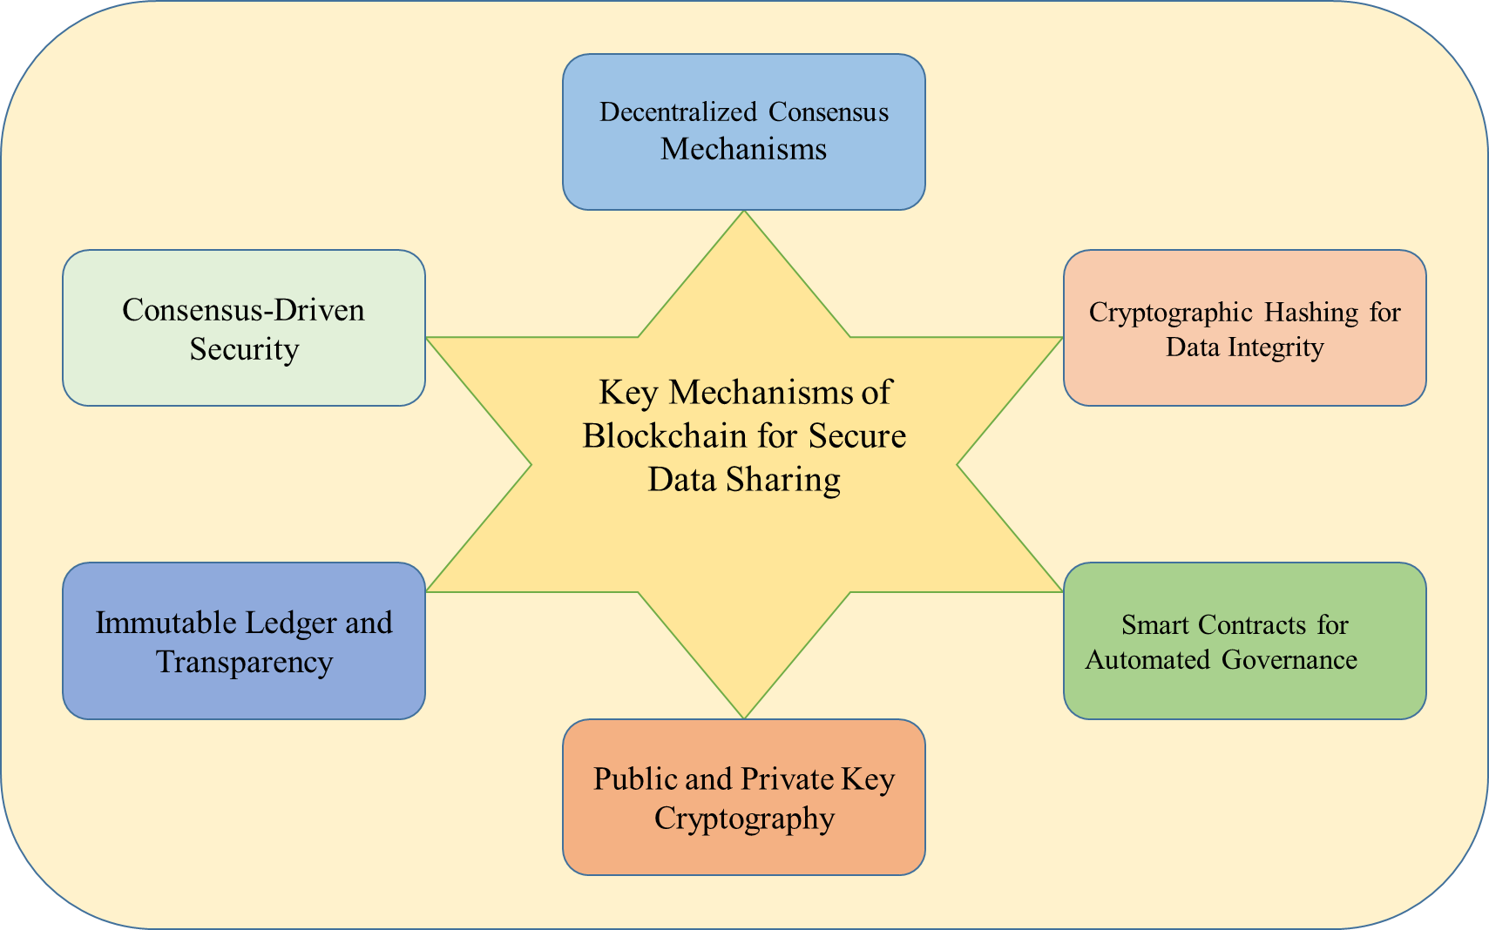

*Figure 6: Key Mechanisms of Blockchain for Secure Data Sharing.*

##### Decentralized Consensus Mechanisms

The consensus protocols like Proof of Work (PoW), Proof of Stake (PoS), and Practical Byzantine Fault

Tolerance (PBFT) serve as crucial mechanisms for authenticating and validating transactions throughout the network. Unlike conventional centralized systems where a sole authority verifies transactions, decentralized consensus ensures that validation is achieved through majority agreement among network participants. This not only to reduce the vulnerability to a single point of failure but also strengthens the integrity of shared data by necessitating consensus across the network.

• *Implications for Secure Data Sharing:* Decentralized consensus mechanisms enhance the resilience of data sharing by eliminating the risks linked with centralized validation. These mechanisms' tamper-resistant properties guarantee that once data is stored on the blockchain, it becomes impervious to unauthorized modifications.

##### Cryptographic Hashing for Data Integrity

Every block within the blockchain includes a distinct cryptographic hash [21], created from the data within that block. This hash acts as a digital signature, making it extremely difficult to modify the block's contents without altering the entire chain, a process that necessitates the agreement of the majority of the network. Therefore, cryptographic hashing is essential for maintaining the immutability and integrity of shared data.

• *Implications for Secure Data Sharing*: Cryptographic hashing serves as a protective measure, guaranteeing that data exchanged on the blockchain remains invulnerable to tampering. This not only boosts the credibility of shared data but also furnishes a dependable means for confirming the legitimacy of information.

##### Smart Contracts for Automated Governance

Smart contracts, which are contracts with pre-established rules encoded on the blockchain and capable of self-execution, bring automation and programmability to blockchain networks. They enable collaboration without the need for intermediaries by automatically executing predetermined rules and agreements. In the context of secure data sharing, smart contracts facilitate automated governance by specifying access permissions, data sharing regulations, and transaction conditions. This not only simplifies the data-sharing procedure but also mitigates the risk of human error and potential conflicts.

• *Implications for Secure Data Sharing*: Smart contracts play a crucial role in creating transparent and automated governance structures, improving the effectiveness and

dependability of data sharing. By integrating rules directly into the blockchain, smart contracts offer a tamper-proof and trust less method for enforcing secure data-sharing agreements.

##### Public and Private Key Cryptography

Blockchain utilizes asymmetric cryptography [22], employing sets of public and private keys to bolster security. Each member of the blockchain network holds a distinct pair of keys.

* *cryptographic keys:* Each participant possesses a public key, which is shared with others, and a private key, which is kept confidential. When data is encrypted with a public key, only the corresponding private key can decrypt it, ensuring secure communication and transaction verification. This cryptographic method enhances the confidentiality of data exchanged within the blockchain.
* *Implications for Secure Data Sharing:* Public and private key cryptography boosts the confidentiality of shared data by guaranteeing that only authorized entities possessing the corresponding private keys can access and decrypt the information.

##### Immutable Ledger and Transparency

The fundamental principle of blockchain revolves around the concept of an unchangeable ledger. Once information is appended to the blockchain, it remains immutable, forming an integral part of the historical record. This permanence guarantees the integrity of data and promotes transparency. Since the blockchain ledger is distributed and openly accessible, authorized participants can review and authenticate the complete transaction history, promoting trust and accountability.

• *Implications for Secure Data Sharing:* The immutable ledger ensures an auditable and transparent trail of shared data, promoting trust among stakeholders and aligning with contemporary demands for openness and accountability in data management practices.

##### Consensus-Driven Security

The security model of blockchain is based on consensus, where the majority of network participants must agree to validate transactions and uphold the integrity of the ledger. This reliance on consensus ensures that any attempt to undermine the system would necessitate control over the majority of the network, making it extremely resilient to malicious attacks and unauthorized modifications.

• *Implications for Secure Data Sharing*: Consensus-driven security establishes a robust defense against potential security threats, providing a resilient foundation for secure data sharing within the blockchain network.

#### 3.1.1 Access Control and Permissions

Access control and permissions form a pivotal aspect of blockchain's secure data sharing paradigm, delineating how users interact with and access shared information within the decentralized network. This subsection explores the nuanced mechanisms embedded in blockchain technology that govern access control and permissions, elucidating their significance in fostering a secure and transparent data-sharing environment.

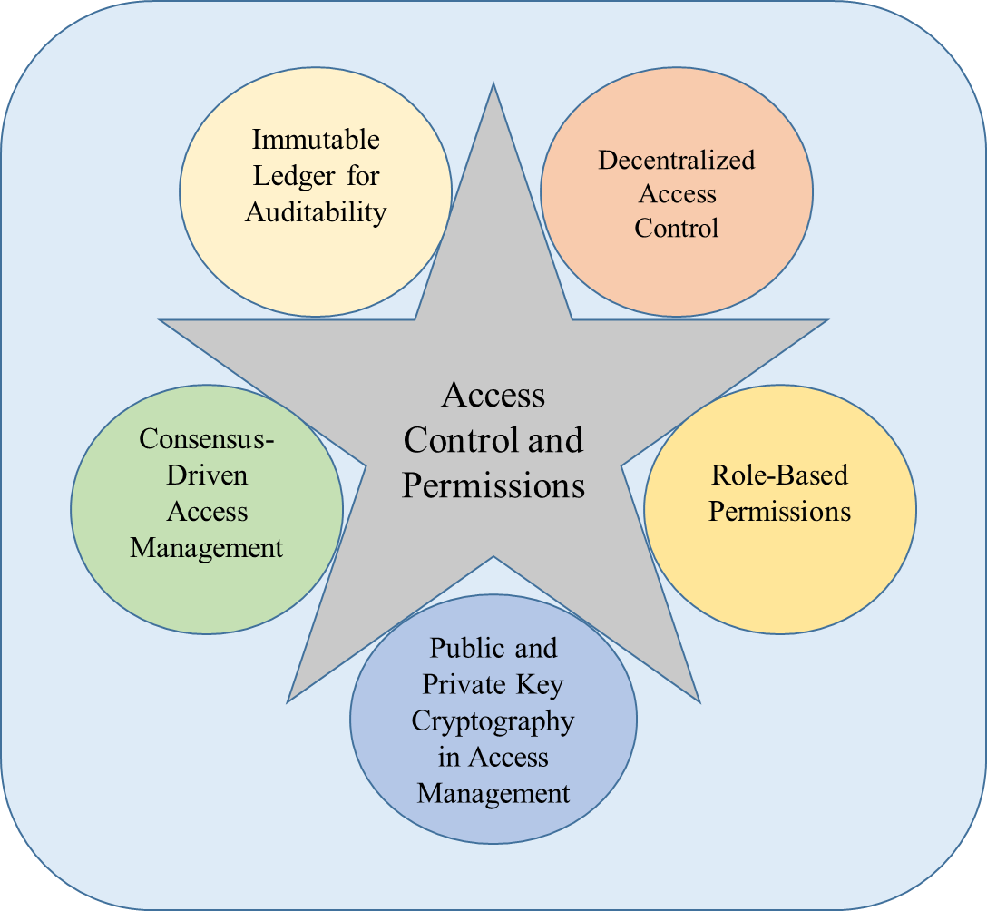

*Figure 7: Access Control and Permissions in cloud Technology.*

###### Decentralized Access Control

The decentralized structure of blockchain revolutionizes conventional access control frameworks. In this decentralized setup, access control is dispersed among numerous nodes, removing the necessity for a central governing body. Smart contracts are instrumental in establishing access control regulations, enabling the automatic and transparent enforcement of predetermined permissions.

* *Smart Contracts as Rule Enforcers*: Smart contracts, imbued with pre-determined instructions, autonomously activate upon meeting certain criteria. These criteria might involve the data access, and alteration, or transaction execution. This decentralized method guarantees that access control isn't dependent on a singular entity but is regulated by the agreement of the network.
* *Transparent Rule Execution:* The transparency ingrained in blockchain guarantees that access control regulations are observable by all network participants. This openness cultivates confidence among users, enabling them to authenticate and confirm the regulations dictating data access. Moreover, the decentralized aspect of smart contracts reduces the likelihood of unauthorized alterations to access control configurations.

###### Role-Based Permissions

Blockchain introduces a role-based approach to access control, where the users are assigned for specific roles that determine their permissions [23] within the network. Roles can range from basic participants to administrators, each having distinct privileges. This role-based model enhances granularity in access control, tailoring permissions based on user responsibilities and requirements.

* *Granular Access Management:* Role-based permissions allow for the granular management of data access. For instance, an organization employing a blockchain network can designate roles such as data viewer, data contributor, and data administrator. Each role carries predefined permissions, preventing unauthorized access and modifications.
* *Dynamic Role Assignment:* The flexibility of blockchain's role-based model enables dynamic assignment and modification of roles. This adaptability proves invaluable in scenarios where user responsibilities evolve, ensuring that access permissions align with organizational changes.

###### Public and Private Key Cryptography in Access Management

Public and private key cryptography reinforces access control by providing a secure mechanism for user identification and verification. Each participant possesses a unique pair of cryptographic keys, enhancing the confidentiality of data access.

* *Secure User Identification:* Individuals are verified and authenticated using their private keys, guaranteeing that solely authorized entities can engage with the blockchain. This cryptographic safeguard enhances the security of access control, rendering it resistant to impersonation and unauthorized entry.
* *Selective Data Encryption:* Public and private key cryptography enables the encryption of data for specific recipients. Information meant for particular users is encrypted using their public key, guaranteeing that only those possessing the corresponding private key can decrypt and access the data. This tailored encryption method bolsters the privacy and confidentiality of shared data.

###### Consensus-Driven Access Management

Access control mechanisms in blockchain rely on network consensus to validate and enforce rules. Consensus ensures that changes to access control settings require majority agreement, adding an additional layer of security against malicious attempts to manipulate permissions.

* *Resistance to Unauthorized Changes:* The consensus-driven approach makes it exceedingly challenging for a single entity to maliciously alter access control settings. Any proposed changes must garner the agreement of the majority, thwarting unauthorized modifications and preserving the integrity of access management.
* *Tamper-Resistant Access Policies:* As access control rules are recorded on the blockchain's immutable ledger, they become resistant to tampering. The historical record of access policies ensures transparency and accountability, allowing stakeholders to trace and verify changes over time.

###### Immutable Ledger for Auditability

Blockchain's immutable ledger contributes to access control auditability, enabling stakeholders to review historical access patterns and changes. The transparent and unchangeable nature of the ledger ensures accountability and fosters trust among users.

* *Auditable Access Logs:* Each modification in access control and every data interaction gets logged on the blockchain, forming a traceable history of access events. This log functions as a detailed register for auditing, enabling organizations to evaluate compliance with security protocols and probe any irregularities.
* *Enhanced Accountability:* The unchangeable ledger improves accountability by offering a clear record of who accessed particular data and at what time. This transparency adheres to regulatory standards and internal organizational guidelines, establishing a sturdy basis for secure data sharing protocols.

#### 3.1.2 Data Encryption and Tamper-Proof Storage

In the realm of blockchain for secure data sharing, the mechanisms of data encryption and tamperproof [24] storage stand as formidable guardians of information integrity and confidentiality. This subsection delves into the intricate workings of these pivotal elements, elucidating their roles in fortifying the security of shared data within decentralized networks.

###### Cryptographic Foundations

At the core of data security within blockchain lies the utilization of cryptographic [25] techniques to encrypt sensitive information. This multifaceted approach employs various cryptographic primitives to safeguard data during storage, transmission, and access.

* *Public-Key Cryptography:* Blockchain utilizes public-key cryptography to establish secure communication channels among participants. Each user is equipped with a distinct public key for encrypting data and a corresponding private key for decryption. This asymmetric encryption guarantees that only authorized parties possessing the correct private key can decrypt and access the encrypted information.
* *Symmetric-Key Cryptography:* In specific scenarios, blockchain utilizes symmetric-key cryptography to efficiently encrypt data. This approach involves using a shared secret key for both encryption and decryption, which streamlines the process while ensuring a high level of security. Symmetric-key cryptography is particularly beneficial for securing substantial amounts of data within the blockchain.

###### End-to-End Encryption for Confidentiality

Blockchain ensures end-to-end encryption to maintain the confidentiality [26] of shared data throughout its lifecycle. Whether data is at rest within the blockchain or in transit between nodes, end-to-end encryption guarantees that only authorized entities possess the means to decipher and comprehend the information.

* *Secure Data Transmission:* When data is transmitted between nodes in the blockchain network, end-to-end encryption safeguards it from interception by unauthorized parties. This cryptographic shield guarantees that even if data packets are intercepted, the contents remain indecipherable without the requisite decryption keys.
* *Confidential Data Storage:* During periods of data dormancy within the blockchain, end-toend encryption persists to shield information from unauthorized access. Each piece of stored data is encrypted with cryptographic keys, rendering it unreadable to any entity lacking the specific decryption credentials.

###### Hash Functions and Data Integrity

To enhance the resistance to tampering of stored data, blockchain incorporates hash functions as a crucial element. These functions produce fixed-size cryptographic hash values that are distinct for each data block, forming a digital signature that encapsulates the integrity of the data.

* *Immutable Data Records:* Every data block stored in the blockchain is associated with its unique hash value, derived from the content of the block. Any alteration to the data block, no matter how minute, results in a substantial change to the hash value. This characteristic ensures the immutability of stored records, as any tampering is detectable through disparities in the hash values.
* *Secure Verification Mechanism:* Hash functions provide a reliable method for verifying data integrity securely. By comparing the current hash value of a data block with its initially recorded hash value, users can easily detect any unauthorized attempts at modification. This verification process strengthens the reliability of data storage within the blockchain.

###### Distributed Storage and Redundancy

The decentralized structure of blockchain inherently enhances tamper-proof storage by dispersing data across numerous nodes in the network. This redundancy [27] guarantees that even if one node is compromised or experiences issues, the data remains secure and accessible from other nodes.

* *Redundant Copies:* Every member of the blockchain network maintains a duplicate of the complete ledger, which includes all stored data. This redundancy minimizes the possibility of data loss or corruption, as multiple identical copies are distributed across the network.
* *Consensus-Driven Data Consistency:* The consensus mechanisms employed by blockchain, such as Proof of Work (PoW) or Proof of Stake (PoS), play a crucial role in maintaining data integrity and safeguarding against tampering. Through consensus, only legitimate, unmodified data blocks are appended to the blockchain, enhancing the network's resilience to malicious alterations.

###### Dynamic Key Management

The dynamism of key management within blockchain adds an additional layer of security to data encryption. Blockchain networks employ dynamic key generation, rotation, and revocation mechanisms to adapt to evolving security landscapes and prevent unauthorized access.

* *Periodic Key Rotation:* To counter potential vulnerabilities associated with long-term key usage, blockchain systems implement periodic key rotation. This practice involves generating new cryptographic keys at regular intervals, reducing the window of opportunity for malicious actors to exploit compromised keys.
* *Revocation Protocols:* In situations where a participant's access privileges need to be revoked, blockchain integrates revocation protocols. These protocols invalidate the compromised keys, ensuring that any attempts by the entity to access encrypted data using outdated credentials are thwarted.

#### 3.1.3 Auditability and Transparency

Within blockchain's architecture secure data sharing, auditability and transparency stand as foundational pillars, fostering trust, accountability, and dependability within the system. This section elucidates the intricate aspects of these essential components, elucidating their significance in strengthening the integrity of data exchanges within decentralized networks.

###### Immutable Ledger as a Transparent Chronicle

The essence of transparency in blockchain resides in its immutable ledger, which chronicles all transactions and data interactions. Every participant within the blockchain network maintains an identical copy of this ledger, guaranteeing a unified and unchangeable view of the complete transaction history.

* *Chronological Order of Transactions:* Blockchain utilizes a consensus-driven method to add new transactions to the ledger, ensuring agreement among all participants regarding the chronological sequence of events. This process establishes a smooth and incontrovertible timeline of data transactions.
* *Decentralized Replication:* Each node in the blockchain network preserves its version of the ledger, promoting decentralized replication. This duplication not only improves data accessibility but also eradicates a sole point of failure, bolstering the resilience of the transparent record.

###### Smart Contracts for Automated Auditing

The integration of smart contracts into blockchain introduces automated audit trails, simplifying the validation of predetermined rules and criteria dictating data transactions. Smart contracts serve as selfexecuting agreements embedded with specific business logic, guaranteeing transparency in fulfilling contractual responsibilities.

* *Predefined Rules for Data Transactions:* Smart contracts enable participants to define predetermined regulations for data access, sharing, and validation, which are autonomously executed. This eradicates the necessity for centralized intermediaries and establishes a transparent framework accessible to all involved parties.
* *Immutable Execution of Business Logic:* After deployment on the blockchain, smart contracts execute immutably. This ensures that the encoded business logic, including audit-related processes, remains inviolable. Participants can conduct audits of smart contract executions with certainty in the consistency and transparency of the results.

###### Cryptographic Signatures for Verification

To further enhance the auditability of data transactions, blockchain leverages cryptographic signatures. Each participant appends a unique digital signature to their transactions, providing an irrefutable link between the transaction and the entity initiating it.

* *Non-Repudiation:* Cryptographic signatures ensure non-repudiation, meaning that the originator of a transaction cannot deny their involvement. This feature enhances the auditability of data interactions by establishing a clear and verifiable trail of transaction initiators.
* *Verification of Transaction Authenticity:* Participants can verify the authenticity of transactions by validating the cryptographic signatures appended to them. This verification process adds an additional layer of transparency, assuring all network participants that the transactions are legitimate and untampered.

###### Consensus Mechanisms for Agreement

The consensus mechanisms of blockchain are crucial for achieving consensus among network participants on transaction validity. They guarantee that only authentic transactions are recorded in the ledger, thereby strengthening the auditability of the complete transaction history.

* *Proof of Work (PoW) and Proof of Stake (PoS):* Common consensus mechanisms like PoW and PoS require participants to demonstrate computational effort or stake assets, proving their commitment to the network. This agreement mechanism adds an additional layer of

transparency, assuring participants that every transaction adheres to the established rules.

* *Unanimity in Transaction Validation:* By achieving consensus, blockchain networks ensure that every participant agrees on the legitimacy of data transactions. This unanimity is foundational for auditability, as it establishes a shared understanding of the accuracy and transparency of the entire ledger.

###### Real-time Transaction Visibility

The decentralized and transparent design of blockchain enables instantaneous visibility into data transactions. Each participant can promptly access the most recent state of the ledger, creating a dynamic setting where modifications are quickly observable, thereby improving overall auditability.

* *Continuous Tracking of Data Movements:* Real-time visibility enables continuous tracking of data movements within the blockchain. Participants can observe, in real-time, any changes to the ledger, promoting transparency and responsiveness to evolving data interactions.
* *Immediate Detection of Anomalies:* The instant visibility of transactions enables participants to promptly identify any irregularities or questionable activities within the network. This proactive stance towards anomaly detection enhances the overall security and auditability of the blockchain ecosystem.

**3.2 Potential Benefits of Using Blockchain**

Blockchain technology, characterized by its decentralized and transparent structure, presents numerous advantages that could significantly transform secure data sharing within cloud environments. This section examines the positive aspects of utilizing blockchain, providing an in-depth analysis of its potential to revolutionize data security and sharing practices.

##### Enhanced Data Security

* Immutable Ledger and Tamper-Proof Storage: The fundamental characteristic of blockchain, its immutable ledger, guarantees that data, once recorded, cannot be tampered with or altered without authorization. This quality of being tamper-proof builds confidence in the integrity of shared data within cloud environments.
* *Cryptographic Techniques for Confidentiality:* Blockchain employs cryptographic techniques such as public-key cryptography and homomorphic encryption, adding robust layers of security to data. These techniques safeguard sensitive information during storage and transmission, ensuring confidentiality in cloud-based data sharing.
* *Smart Contracts for Automated Security Measures:* Incorporating smart contracts automates and enforces security protocols, diminishing dependence on centralized intermediaries. These self-executing codes within the blockchain guarantee adherence to predefined rules for data access and sharing, thereby bolstering data security overall.

##### Transparency and Accountability

* *Immutable Ledger for Transparent Transactions*: The decentralized and unchangeable characteristic of the blockchain ledger guarantees transparent and auditable transactions. Every participant holds an identical version of the ledger, establishing a collective and immutable log of data exchanges.
* *Smart Contracts for Automated Auditing*: Smart contracts streamline auditing processes by automating the verification of predefined rules and conditions. This enhances accountability and transparency by eliminating the need for manual intervention in ensuring adherence to data sharing agreements.
* *Cryptographic Signatures for Verifiable Transactions*: Cryptographic signatures add an extra layer of transparency by providing verifiable links between transactions and their initiators. This non-repudiation feature ensures that participants cannot deny their involvement in transactions, bolstering overall accountability.

##### Decentralization and Resilience

* *Decentralized Consensus Mechanisms:* Blockchain utilizes consensus mechanisms such as Proof of Work (PoW) and Proof of Stake (PoS) to authenticate transactions. This decentralization fortifies the system against vulnerabilities stemming from singular points of failure, thus bolstering the resilience of data sharing within cloud environments.
* *Reduced Dependency on Centralized Entities:* Blockchain reduces dependency on centralized entities, fostering a more distributed and resilient data storage infrastructure. This independence mitigates risks associated with reliance on a single authority and contributes to a more reliable data sharing ecosystem.

##### Efficient and Trustless Collaboration

* *Smart Contracts Enabling Trustless Collaboration:* Incorporating smart contracts enables trust less collaboration by automating and enforcing secure data sharing agreements. This eliminates the necessity for centralized intermediaries, simplifying processes and fostering trust among participants in the ecosystem.
* *Real-time Visibility for Improved Collaboration:* Blockchain's real-time visibility into data transactions enhances collaboration by providing continuous tracking of data movements. Participants can immediately detect and respond to changes, contributing to a dynamic and responsive collaborative environment.

##### User-Centric Control and Privacy Preservation

* *Evolving Consent Mechanisms*: The development of blockchain technology involves improvements in user-oriented management of shared data. Evolving consent mechanisms empower individuals to exert precise control over their data, fostering the creation of usercentric and privacy-focused ecosystems within cloud-based data sharing frameworks.
* *Decentralized Identity Management:* Blockchain's involvement in decentralized identity management guarantees individuals greater authority over their personal data. This transition from centralized identity repositories to blockchain-driven solutions reduces the vulnerabilities linked with centralized databases, thereby improving overall privacy in data sharing procedures.

#### 3.2.1 Enhanced Security and Privacy

Blockchain technology introduces a paradigm shift in the realms of security and privacy [28], offering a robust framework for secure data sharing within cloud environments. This subsection delves into the nuanced aspects of how blockchain enhances security and privacy, contributing to a resilient and trustcentric ecosystem.

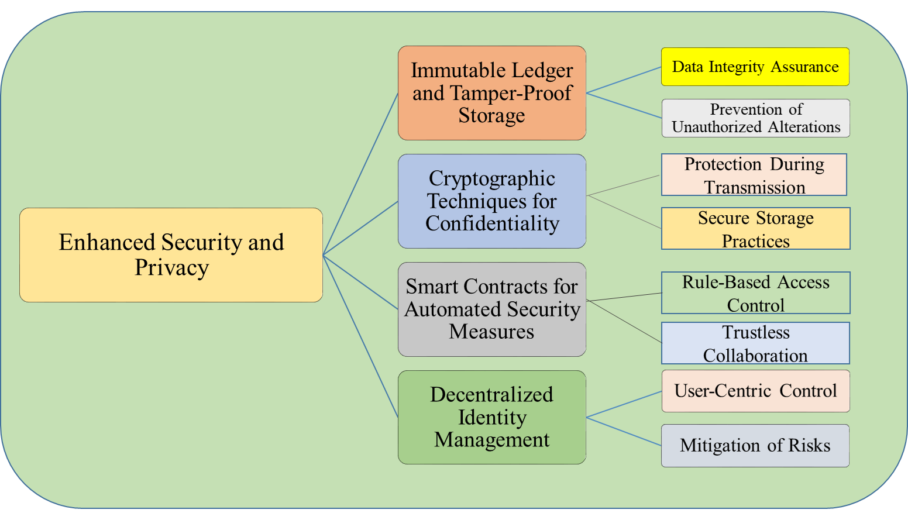

*Figure 8: Enhanced Security and Privacy in cloud Technology.*

###### Immutable Ledger and Tamper-Proof Storage

Blockchain's foundational strength lies in its immutable ledger, providing an unalterable record of transactions. Once data is recorded, it becomes resistant to tampering and unauthorized alterations. This tamper-proof storage ensures the integrity of shared data within cloud environments, enhancing overall security.

* *Data Integrity Assurance:* The unchangeable nature of the blockchain ledger ensures the integrity of data. Every transaction is time stamped and connected to the preceding one, forming an immutable and verifiable chain. This characteristic is essential for thwarting data tampering and upholding the reliability of information.
* *Prevention of Unauthorized Alterations:* The decentralized nature of blockchain, coupled with cryptographic hashing, ensures that once data is added to a block, altering it would require changing all subsequent blocks. This level of security prevents unauthorized alterations, making blockchain an effective tool for safeguarding data in cloud-based environments.

###### Cryptographic Techniques for Confidentiality

Blockchain utilizes sophisticated cryptographic methods like public-key cryptography and homomorphic encryption to enhance data confidentiality during both storage and transmission. These methods are crucial for safeguarding sensitive data and reducing vulnerabilities in data sharing within cloud environments.

* *Protection during Transmission:* Public-key cryptography encrypts data during transmission, ensuring that even if intercepted, the information remains secure. This cryptographic layer adds an extra dimension of protection, crucial in cloud environments where data is frequently transmitted across networks.
* *Secure Storage Practices:* Homomorphic encryption enables computations to be executed on encrypted data without requiring decryption. In the realm of blockchain, this capability ensures that data remains secure while preserving its confidentiality. By incorporating such cryptographic techniques, blockchain adopts a multi-layered strategy to protect sensitive information.

###### Smart Contracts for Automated Security Measures

Incorporating smart contracts into blockchain technology brings automated security protocols, lessening dependence on centralized intermediaries. These self-executing contracts enforce predetermined rules, guaranteeing secure data sharing arrangements without requiring continual manual supervision.

* *Rule-Based Access Control:* Smart contracts enable rule-based access control, dictating how data should be accessed and shared. This automation not only streamlines processes but also eliminates the potential for human error in enforcing security measures, enhancing overall data protection.
* *Trustless Collaboration:* The programmable logic embedded in smart contracts facilitates trust less collaboration. Participants can engage in data transactions knowing that the agreed-upon rules will be automatically enforced. This trust less nature eliminates the need for blind trust in intermediaries, further securing data sharing processes.

###### Decentralized Identity Management

Blockchain's role in decentralized identity management contributes significantly to enhancing user privacy. By shifting from centralized repositories to blockchain-based solutions, individuals gain more control over their personal information, reducing the risks associated with centralized identity systems. • *User-Centric Control:* Decentralized identity solutions provide users with precise control over their personal data. Users can specify who can access particular information, in line with evolving consent mechanisms in blockchain. This user-centric control is crucial for maintaining privacy within cloud-based data sharing frameworks.

• *Mitigation of Risks:* The cryptographic principles and decentralized architecture of blockchain help alleviate the vulnerabilities linked to centralized identity repositories. By removing a single point of failure, the risk of extensive data breaches is minimized, resulting in a more secure and private identity management system.

#### 3.2.2 Increased Trust and Transparency

Blockchain technology introduces a paradigm shift in fostering increased trust and transparency within data sharing ecosystems. This subsection explores the multifaceted ways in which blockchain enhances trust and transparency, contributing to a more accountable and reliable framework for secure data sharing in cloud environments.

###### Decentralized Consensus Mechanisms

Blockchain utilizes decentralized consensus mechanisms like Proof of Work (PoW), Proof of Stake (PoS), and Practical Byzantine Fault Tolerance (PBFT) to establish trust and transparency across the network.

* *Immutable Record of Transactions:* Utilizing decentralized consensus, every transaction undergoes validation and inclusion in the blockchain via a network of distributed nodes. This mechanism guarantees the integrity and immutability of the transaction history, fostering confidence in the reliability of the shared data.
* *Elimination of Single Points of Failure*: Decentralized consensus diminishes dependency on individual points of failure, bolstering the network's resilience. This absence of a central authority elevates trust by eliminating the potential for compromising the integrity of shared data.

###### Transparent Audit Trails

The transparent and unchangeable ledger of blockchain generates a thorough record of every transaction and data exchange. This transparency nurtures trust among users and offers a reliable log of all activities.

• *Accountability through Visibility:* Every data transaction is recorded in a chronological order, creating a transparent trail of activities. This not only ensures accountability but also facilitates the identification of any irregularities or unauthorized access, thus strengthening trust among participants.

*Streamlined Auditing Processes:* The inherent transparency of blockchain simplifies auditing processes. Auditors can efficiently trace the history of transactions and verify compliance with established rules. This streamlined auditing contributes to a trustworthy data-sharing environment.

###### Smart Contracts for Automated Compliance

The integration of smart contracts introduces automated compliance measures, ensuring that predefined rules and agreements are automatically enforced. This automation enhances trust among participants, as the execution of agreements is transparent and tamper-proof.

* *Code as Law:* Smart contracts embody the concept of "code as law," where the agreed-upon rules and conditions are written into the code. This automated execution eliminates the need for blind trust, as participants can rely on the transparent and predictable outcomes defined in the smart contract.
* *Reduction of Ambiguity:* By automating compliance measures, smart contracts reduce ambiguity and interpretation discrepancies. Participants can trust that the execution of agreements is based on predetermined rules, fostering a transparent and trustworthy data sharing environment.

###### Cross-Industry Collaboration and Insights

Blockchain facilitates cross-industry collaboration, bringing together diverse stakeholders such as blockchain experts, data scientists, legal scholars, and industry professionals. This collaboration contributes to a holistic understanding of data-sharing practices, promoting transparency across various domains.

• *Comprehensive Insights*: The collaboration of experts from different fields enriches the discourse on secure data sharing. Insights gained from diverse perspectives provide a comprehensive view of challenges, solutions, and best practices, fostering transparency in the approach to data security.

*Alignment with Regulatory Standards:* The combined knowledge and skills guarantee that blockchain solutions comply with regulatory requirements and ethical guidelines. This conformity fosters trust among stakeholders, reassuring them that data-sharing practices are in accordance with legal and ethical standards.

#### 3.2.3 Improved Data Traceability and Accountability

Blockchain technology introduces a transformative impact on data traceability and accountability, enhancing the reliability of secure data sharing in cloud environments. This subsection delves into the mechanisms and benefits that contribute to improved traceability and accountability within blockchain based systems.

###### Decentralized Ledger for Unalterable Records

Blockchain's core feature, a decentralized and immutable ledger, plays a pivotal role in improving data traceability and accountability.

* *Chronological Record Keeping:* Each data exchange is time-stamped and connected to the previous one, forming an immutable sequence of records. This chronological arrangement improves traceability, enabling participants to track the complete history of data interactions and modifications.
* *Tamper-Proof Data Integrity:* The decentralized nature ensures that once data is recorded, it becomes resistant to tampering. This tamper-proof characteristic guarantees the integrity of the data, instilling confidence in its accuracy and origin.

###### Smart Contracts for Automated Accountability

The integration of smart contracts introduces automated accountability measures, ensuring that predefined rules and agreements are automatically enforced without the need for intermediaries.

*Automated Execution of Agreements:* Smart contracts encode business logic and contractual terms into code, automating the execution of agreements. This automation ensures that participants are held accountable for adhering to predefined rules without the need for manual oversight.

• *Transparent and Verifiable Execution*: The execution of smart contracts is transparent and verifiable on the blockchain. Participants can independently verify that the terms of agreements have been met, enhancing accountability and reducing the risk of disputes.

###### Immutable Audit Trails for Enhanced Traceability

Blockchain's transparent and immutable audit trails contribute significantly to improved traceability within the data-sharing ecosystem.

* *Comprehensive Record of Transactions:* The transparent ledger provides a comprehensive record of all transactions. This includes details such as data access, sharing, and any changes made to the data. This comprehensive record improves traceability by offering a clear and unambiguous history.
* *Simplified Auditing Processes:* Auditing becomes simplified due to the unchangeable nature of the blockchain, guaranteeing the reliability of recorded transactions. The capacity to track data interactions facilitates the detection of anomalies and upholds accountability throughout the system.

###### Cross-Referencing and Provenance Verification

Blockchain enables cross-referencing of data and verification of its provenance, enhancing traceability and accountability.

• *Cross-Referencing Data Sources:* Participants can cross-reference data from multiple sources on the blockchain. This cross-referencing capability ensures that data inconsistencies can be identified, contributing to improved traceability and data quality.

*Provenance Verification:* Blockchain's capability to trace the origin of data ensures that participants can verify the authenticity and reliability of the information. Provenance verification adds an additional layer of accountability, as the origin and journey of data are transparently recorded.

# Chapter 4: Challenges and Limitations

Blockchain technology has emerged as a promising solution for enhancing data security and transparency in cloud environments. By leveraging decentralized ledger technology, blockchain can address various challenges associated with traditional cloud storage models, such as data breaches, unauthorized access, and tampering.

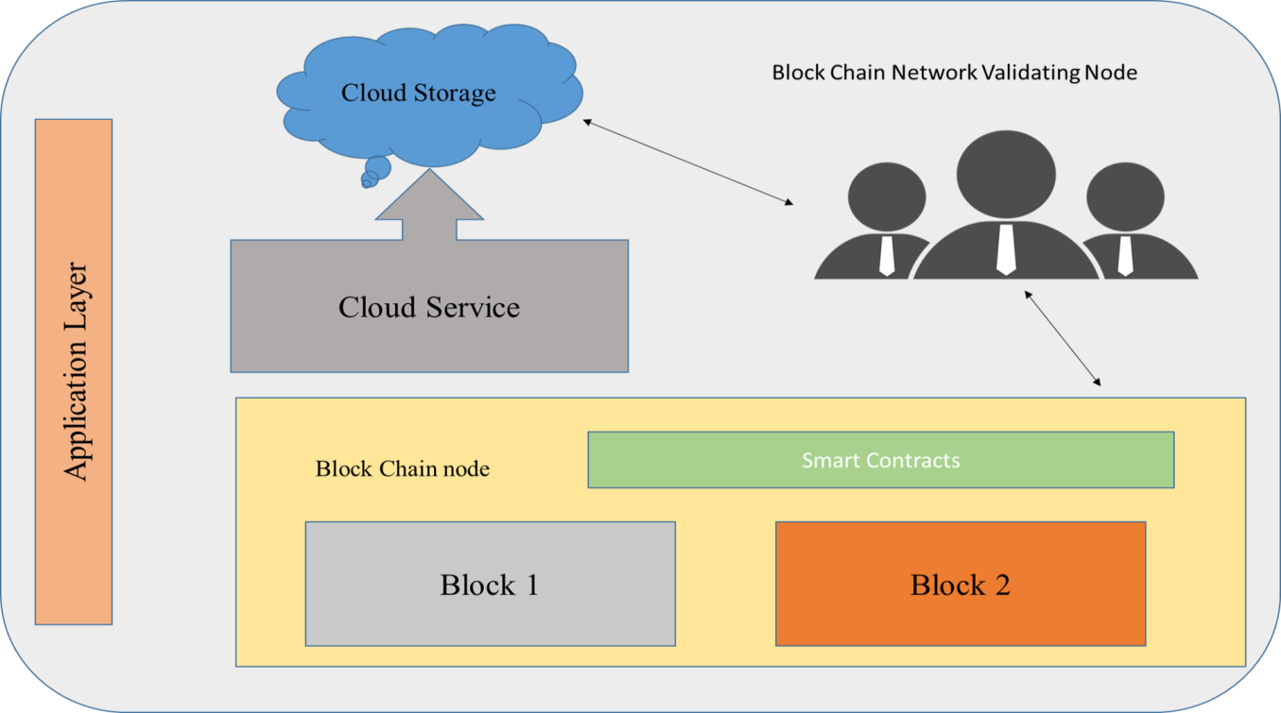

*Figure 9: Architecture of Block Chain in Cloud Environment.*

In a cloud environment, blockchain offers several advantages, including:

* *Enhanced Data Security***:** The decentralized structure and cryptographic features of blockchain guarantee the security and integrity of data stored in the cloud. Every transaction is cryptographically connected to the one before it, establishing an unchangeable and transparent log of data exchanges.
* *Transparency and Auditability***:** The transparency inherent in blockchain allows all authorized participants to access and confirm transactions logged on the ledger. This transparency boosts accountability and streamlines auditing procedures, particularly vital in cloud settings where numerous entities cooperate and exchange data.
* *Decentralization for Resilience:* Decentralization in blockchain architecture mitigates the risk of single points of failure, ensuring continuous access to data even in the event of network disruptions or malicious attacks. This resilience is particularly valuable in cloud environments where data availability is paramount.
* *Smart Contract Integration:* Blockchain platforms frequently incorporate smart contracts, which are automated contracts with predetermined conditions. These smart contracts streamline operations and enforce agreements between parties, diminishing reliance on intermediaries in transactions conducted in cloud environments.

### 4.1 Scalability and Performance Limitations of Blockchain Technology

Blockchain technology, while offering numerous benefits, is not without its challenges, particularly concerning scalability and performance. This subsection explores the inherent limitations that blockchain faces in scaling to meet the demands of large-scale data sharing in cloud environments.

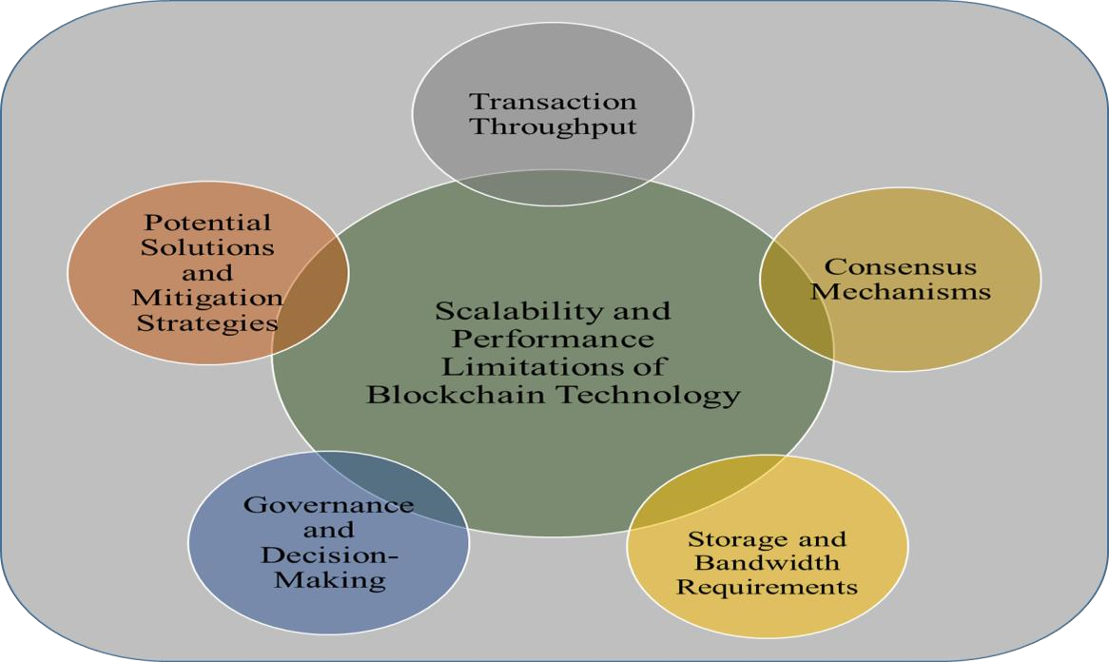

*Figure 10: Scalability and Performance Limitations of Blockchain Technology.*

## Transaction Throughput

* *Limited Transaction Processing Speed:* One of the main issues related to scalability in blockchain technology is its restricted transaction processing capacity. Conventional blockchain networks like Bitcoin and Ethereum demonstrate relatively slow transaction processing speeds. For instance, Bitcoin can handle approximately seven transactions per second (tps), while Ethereum's throughput is slightly higher but remains constrained.
* *Bottlenecks in Network Congestion***:** As transaction volumes rise, blockchain networks frequently encounter congestion, resulting in delays and higher transaction fees. This congestion stems from the limited block capacity and the competition among transactions to be included in the subsequent block.

##### Consensus Mechanisms

* *Resource-Intensive Consensus Algorithms***:** Several blockchain networks utilize consensus mechanisms, like Proof of Work (PoW), known for their computational intensity. In PoW, miners must solve intricate mathematical puzzles to authenticate transactions and incorporate them into the blockchain. This method demands substantial computational resources, thereby constraining the network's scalability.
* *Latency in Block Confirmation:* The consensus mechanism employed by blockchain networks introduces delays in confirming blocks. For instance, in PoW-based networks like Bitcoin, blocks are mined at fixed intervals, usually approximately every 10 minutes. This delay impacts transaction finality and the overall throughput of the network.

##### Storage and Bandwidth Requirements

* *Growing Blockchain Size:* As additional transactions are incorporated into the blockchain, the blockchain's size expands progressively. This expansion presents difficulties for network participants, especially those operating full nodes, as they are required to store and synchronize the complete blockchain. The increasing storage requirements can deter participation, leading to centralization risks.
* *Bandwidth Constraints***:** Blockchain networks encounter limitations in bandwidth, particularly in situations where extensive data volumes must be distributed across the network. The necessity to disseminate blocks and transactions to every network node can impose pressure on network bandwidth, affecting overall operational efficiency.

##### Governance and Decision-Making

* *Challenges in Network Governance:* Governance structures within blockchain networks can impact scalability and performance. Disagreements among network participants on protocol upgrades or changes can lead to network forks and fragmentation, affecting transaction throughput and reliability.
* *Slow Evolution of Protocols:* The decentralized nature of blockchain governance can result in slow decision-making processes for protocol upgrades. This sluggish evolution hampers the ability of blockchain networks to adapt to changing scalability requirements and technological advancements.

##### Potential Solutions and Mitigation Strategies

* *Layer-2 Scaling Solutions:* Scaling solutions at Layer-2, like the Lightning Network for Bitcoin and state channels for Ethereum, are designed to enhance scalability by diverting transactions away from the primary blockchain. Their objective is to facilitate quicker and more cost-effective transactions by executing them off-chain and settling them intermittently on the main blockchain.
* *Consensus Algorithm Innovations***:** Advancements in consensus algorithms, such as Proof of Stake (PoS) and its variations like Delegated Proof of Stake (DPoS), are targeted at resolving the scalability constraints associated with Proof of Work (PoW). These PoS-based algorithms demand less computational resources, resulting in quicker block confirmations and increased transaction throughput.
* *Sharding and Partitioning:* Sharding is a technique that entails splitting the blockchain network into smaller sections, or sharding [29], each equipped to handle a portion of the transactions. This segmentation enables simultaneous processing of transactions, offering a substantial enhancement in scalability. Ethereum 2.0 is currently investigating the implementation of sharding to address scalability issues.

### 4.2 Regulatory and Legal Considerations of Blockchain-Based Data Sharing

Sharing data through blockchain technology introduces specific regulatory and legal hurdles that require meticulous handling to adhere to regulations and minimize potential risks. This section delves into the essential aspects concerning regulatory structures, privacy statutes, and the enforceability of smart contracts within the realm of blockchain technology.

##### Regulatory Frameworks

* *Jurisdictional Ambiguity:* Blockchain operates on a decentralized and global scale, which can pose challenges for regulatory oversight. Determining the applicable jurisdiction for blockchain transactions and data sharing activities becomes complex, especially when participants are distributed across multiple countries with differing regulatory regimes.
* *Regulatory Compliance:* Organizations engaging in blockchain-based data sharing must adhere to relevant regulatory requirements, such as anti-money laundering (AML) and knowyour-customer (KYC) regulations. Ensuring compliance with these regulations is essential to mitigate legal risks and maintain trust with stakeholders.

##### Data Privacy Laws

* *GDPR Compliance:* The European Union's General Data Protection Regulation (GDPR) sets forth stringent guidelines for handling and transferring personal data. However, blockchain's inherent immutability and decentralized structure may pose challenges to GDPR principles, including the right to erasure (right to be forgotten) and the obligation for data controllers to retain control over data.
* *Data Sovereignty:* The utilization of blockchain for data sharing often entails storing and transferring data internationally. Laws on data sovereignty, which specify the permissible locations for data storage and processing, can influence the deployment of blockchain systems. Organizations need to take into account data residency regulations and ensure adherence to applicable legal statutes.

##### Smart Contract Enforceability

* *Legal Validity:* Smart contracts, which automate and execute agreements on the blockchain, prompt inquiries into their legal standing and enforceability. Despite the efficiency and transparency they provide, their validity hinges on conventional legal systems and the acknowledgment of code as a binding element by judicial authorities.
* *Contractual Ambiguity***:** Ambiguities in smart contract code or discrepancies between code and intended contractual terms can lead to disputes and legal challenges. Ensuring that smart contracts are accurately drafted and reflect the parties' intentions is crucial to avoid potential legal pitfalls.

##### Interoperability and Standards

* *Interoperability Challenges:* has lack of interoperability between different blockchain platforms and protocols poses a significant challenge as blockchain networks frequently operate independently. This limitation can impede data sharing and collaboration initiatives, especially in multi-party environments where participants utilize various blockchain solutions.
* *Need for Standardization:* Establishing industry-wide standards for blockchain-based data sharing can facilitate interoperability and promote regulatory compliance. Standardization efforts around data formats, cryptographic protocols, and smart contract templates can streamline integration and enhance trust among participants.

##### Risk Management and Compliance

* *Due Diligence:* Organizations involved in blockchain-based data sharing need to conduct comprehensive due diligence to evaluate legal and regulatory risks. This process entails identifying relevant laws and regulations, assessing the compliance of blockchain solutions, and implementing strategies to mitigate risks.
* *Regulatory Monitoring***:** Given the evolving nature of blockchain regulations, organizations must stay informed about changes in legal requirements and regulatory interpretations. Continuous monitoring of regulatory developments enables proactive compliance efforts and reduces the risk of non-compliance penalties.

### 4.3 Integration Challenges with Existing Cloud Infrastructure

Integrating blockchain technology [30] with existing cloud infrastructure presents a range of challenges that organizations must address to ensure seamless deployment and interoperability. This subsection explores the key integration challenges, including compatibility issues, scalability concerns, and data migration complexities.

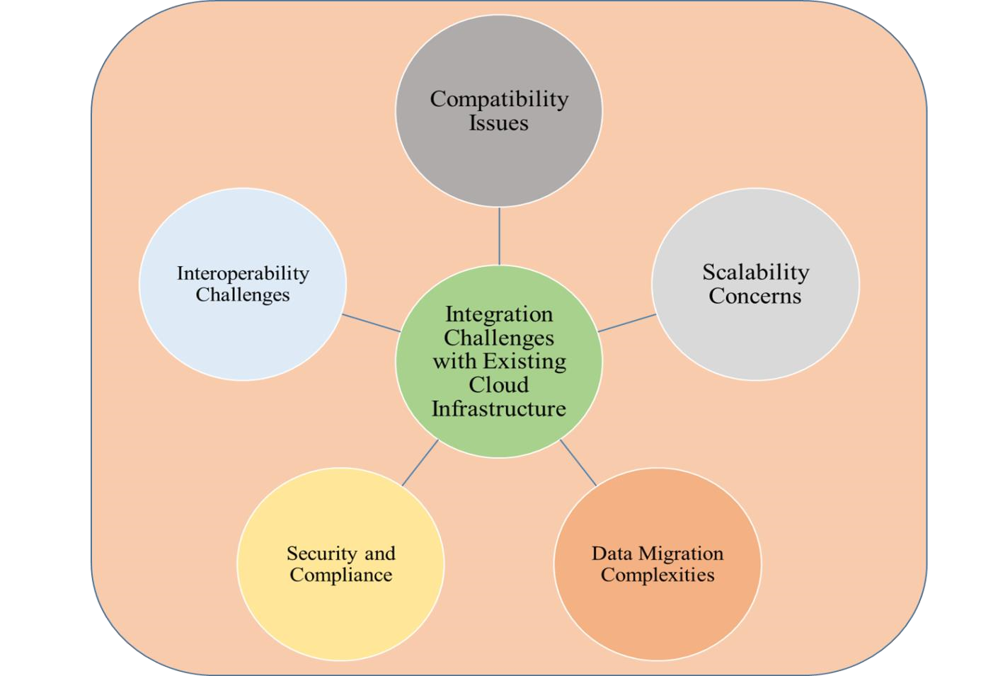

*Figure 11: Integration Challenges with Existing Cloud Infrastructure.*

##### Compatibility Issues

* *Protocol Misalignment:* The integration of various blockchain networks often involves different protocols and consensus mechanisms that might not seamlessly align with existing cloud infrastructure. Therefore, integrating these diverse the systems requires meticulous consideration of protocol compatibility to facilitate uninterrupted data transmission and transaction processing.
* *Legacy System Integration:* Numerous organizations rely on legacy systems that do not inherently support blockchain technology. Incorporating blockchain into legacy infrastructure can pose challenges owing to disparities in data formats, communication protocols, and security measures. Upgrading legacy systems to accommodate blockchain necessitates substantial investments of time and resources.

##### Scalability Concerns

* *Performance Bottlenecks:* The decentralized structure and consensus mechanisms of blockchain have the potential to create performance bottlenecks, particularly in extensive implementations. Scalability issues might emerge when handling substantial transaction volumes or managing large data storage on the blockchain. It's crucial to prioritize sufficient throughput and effective latency management to sustain performance levels.
* *Resource Intensiveness:* Blockchain nodes consume significant computational resources, including processing power, memory, and storage. Integrating blockchain with existing cloud infrastructure may strain resource allocation and impact overall system performance. Organizations must carefully assess resource requirements and scalability limitations to prevent resource exhaustion and system slowdowns.

##### Data Migration Complexities

* *Data Consistency***:** Migrating data from existing cloud databases to blockchain platforms requires ensuring data consistency and integrity. Synchronization challenges may arise when transferring large datasets or real-time data streams to the blockchain. Maintaining data consistency across distributed systems is critical to prevent data corruption and ensure accuracy.
* *Data Format Compatibility:* Blockchain platforms may have specific data format requirements that differ from existing cloud databases. Converting data formats and structures to align with blockchain standards can be time-consuming and error-prone. Data transformation tools and middleware solutions may be necessary to facilitate seamless data migration.

##### Security and Compliance

* *Security Risks:* Incorporating blockchain into current cloud infrastructure introduces fresh security challenges and potential attack routes. Weaknesses in cloud services or blockchain nodes may jeopardize the confidentiality and integrity of shared data across systems. Deploying strong security protocols like encryption, access controls, and intrusion detection becomes imperative to counter these security risks effectively.
* *Regulatory Compliance:* Blockchain deployments must adhere to regulatory requirements governing data protection, privacy, and financial transactions. Integrating blockchain with existing cloud infrastructure may necessitate updates to compliance policies and procedures to ensure alignment with regulatory standards. Failure to comply with regulatory mandates can result in legal consequences and reputational damage.

##### Interoperability Challenges

* *Platform Fragmentation:* The widespread adoption of various blockchain platforms and protocols has resulted in platform fragmentation, posing challenges for interoperability between different systems. When integrating blockchain with current cloud infrastructure, efforts may be needed to bridge diverse platforms and establish interoperability standards to enable smooth data exchange and transaction processing.
* *Smart Contract Compatibility***:** Smart contracts deployed on different blockchain platforms may not be compatible due to differences in programming languages and execution environments. Ensuring interoperability between smart contracts and existing cloud services requires standardization efforts and cross-platform compatibility testing.

# Chapter 5. Market Potential of Blockchain in Secure Data Sharing

### 5.1 Drivers for Adoption

The adoption of blockchain technology for secure data sharing in cloud environments is propelled by several compelling drivers, reflecting the urgent need for enhanced data security, regulatory compliance, and trust among stakeholders. These drivers serve as catalysts for organizations to explore blockchainbased solutions as viable alternatives to traditional centralized data storage models.

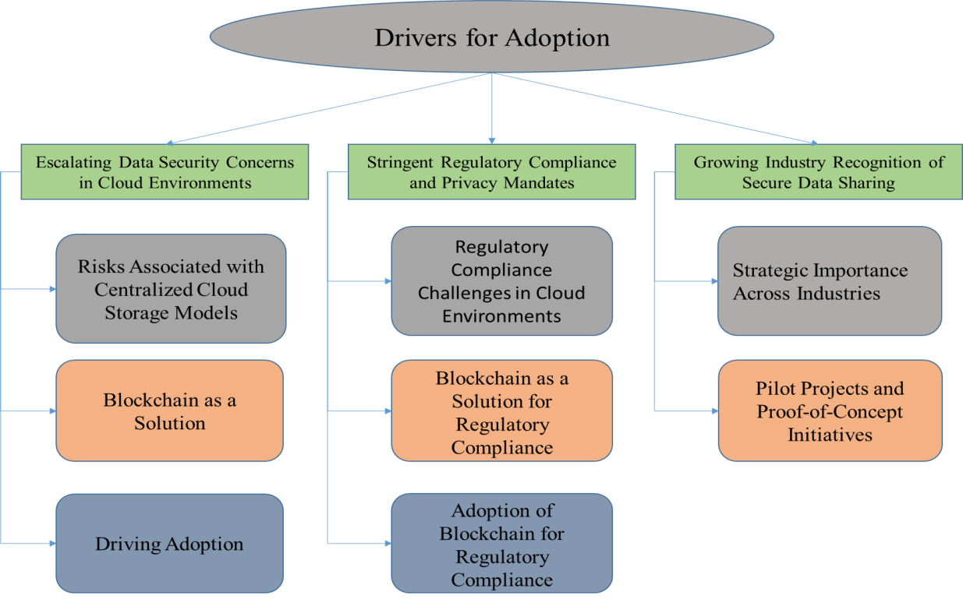

*Figure 12: Secure data sharing in cloud environments with Drivers Adoption.*

#### 5.1.1 Escalating Data Security Concerns in Cloud Environments

The emergence of cloud computing has initiated a fresh phase in data storage, processing, and accessibility for global organizations. Providing unmatched scalability, adaptability, and cost-effectiveness, cloud services have become indispensable to contemporary business functions. Nonetheless, this convenience brings inherent risks, primarily originating from the centralized structure of conventional cloud storage models.

###### Risks Associated with Centralized Cloud Storage Models

* *Data Breaches:*Cybercriminals find centralized cloud storage [31] systems appealing because they contain valuable data in one place. Incidents of data breaches can result in severe consequences, including financial losses, harm to reputation, and legal actions against impacted organizations.
* *Unauthorized Access:*Enterprises relying on conventional cloud storage frameworks might encounter difficulties in preserving precise control over access privileges, heightening the likelihood of unauthorized entry to confidential data. Unauthorized access by malicious entities or unapproved users to crucial information can jeopardize both confidentiality and integrity, presenting substantial security concerns.
* *Data Tampering:*The centralized architecture of traditional cloud storage systems exposes them to the risk of data tampering. Unauthorized modifications or alterations to stored data can go unnoticed, leading to misinformation, loss of trust, and regulatory non-compliance.

###### Blockchain as a Solution

Blockchain technology presents an enticing remedy for these security apprehensions by dispersing data storage and administration. Unlike the conventional centralized cloud storage systems, where data is housed in servers governed by a solitary entity, blockchain disperses data across a network of nodes, guaranteeing redundancy and robustness.

* *Distributed Ledger Architecture:* The distributed ledger structure of blockchain guarantees the replication and synchronization of data across numerous nodes within the network. Each node retains an identical version of the ledger, eradicating single points of failure and diminishing the likelihood of data tampering or loss.
* *Cryptographic Algorithms***:** Blockchain utilizes cryptographic algorithms to protect data stored on the ledger. Transactions undergo cryptographic hashing and are connected to preceding transactions, establishing an unchangeable and resistant record of data transactions. Any effort to tamper with stored data necessitates agreement from a majority of nodes in the network, rendering it highly improbable to modify historical records without detection.
* *Transparent Data Management:* Blockchain's transparency ensures that all data interactions are recorded on the ledger in a transparent and auditable manner. Organizations can track the origin, ownership, and history of data stored on the blockchain, facilitating accountability and compliance with regulatory requirements.

###### Driving Adoption

The escalating frequency and sophistication of cyberattacks have underscored the urgency for organizations to fortify their data protection measures. Blockchain's ability to enhance data security in cloud environments by decentralizing storage, ensuring immutability, and providing transparent data management has positioned it as a compelling solution for organizations keen on safeguarding their sensitive data. As a result, the adoption [32] of blockchain technology in cloud environments is on the rise, with organizations recognizing its potential to mitigate security risks and bolster data protection measures.

#### 5.1.2 Stringent Regulatory Compliance and Privacy Mandates

The changing regulatory environment concerning data privacy and security has prompted organizations in cloud settings to emphasize compliance with strict laws such as the General Data Protection Regulation

(GDPR) and the California Consumer Privacy Act (CCPA). Failure to adhere to these regulations can lead to significant penalties and harm to reputation, highlighting the necessity of adopting effective data protection strategies.

###### Regulatory Compliance Challenges in Cloud Environments

* *GDPR and CCPA Compliance***:** The GDPR and CCPA establish extensive regulations

concerning data privacy and protection, dictating stringent protocols for the acquisition, retention, and handling of personal information by companies. Meeting the criteria set forth by these regulations poses a significant challenge, especially in cloud setups, where data is frequently dispersed across various servers and legal jurisdictions.

* *Data Sovereignty Concerns:* Many regulations, including GDPR, stipulate that organizations must ensure data sovereignty by storing and processing personal data within the boundaries of specific geographic regions or jurisdictions. Traditional cloud storage models may struggle to guarantee data sovereignty, posing compliance challenges for organizations operating across multiple jurisdictions.

###### Blockchain as a Solution for Regulatory Compliance

Blockchain technology presents an attractive option for adhering to regulatory standards by incorporating privacy-enhancing functionalities directly within its framework. The core attributes of blockchain, such as immutability, transparency, and cryptographic protection, closely resonate with the principles outlined in data privacy regulations.

* *Immutable and Transparent Ledger:* The immutable ledger of blockchain guarantees the permanent recording of all data transactions, preventing retroactive alteration or deletion. This characteristic supports regulatory adherence by offering a transparent and auditable history of data interactions. Consequently, organizations can showcase compliance with regulatory mandates during audits or inquiries.
* *Cryptographic Security*: Blockchain's cryptographic algorithms provide robust data encryption and access controls, ensuring that sensitive information remains secure and tamper-proof. By leveraging cryptographic [33] principles, organizations can protect personal data from unauthorized access or manipulation, thereby meeting the stringent security requirements mandated by regulations like GDPR and CCPA.

###### Adoption of Blockchain for Regulatory Compliance

As organizations grapple with the challenges of achieving regulatory compliance in cloud environments, blockchain technology emerges as a viable solution for addressing these challenges effectively. By embedding privacy-enhancing features directly into its architecture, blockchain enables organizations to achieve compliance with regulations like GDPR and CCPA while maintaining data integrity, transparency, and security. Consequently, the adoption of blockchain technology for regulatory compliance is gaining momentum, with organizations recognizing its potential to enhance data protection measures and mitigate regulatory risks in cloud environments.

#### 5.1.3 Growing Industry Recognition of Secure Data Sharing

In recent years, there has been a notable shift across various industries towards recognizing the strategic importance of secure data sharing [34] in fostering innovation, collaboration, and operational efficiency. This recognition has prompted organizations to explore and adopt blockchain-based solutions as a means of addressing data security challenges inherent in cloud environments.

###### Strategic Importance Across Industries

* *Healthcare Sector:* Healthcare institutions have been leading the way in embracing blockchain technology to tackle data security issues. Especially, healthcare consortia have utilized blockchain to create interconnected systems for sharing patient records among healthcare providers. Through blockchain implementation, these consortia guarantee the confidentiality and protection of sensitive health [35] data while streamlining the process of data exchange and cooperation.
* *Financial Industry:* The financial industry has acknowledged the value of blockchain in bolstering data security and simplifying intricate transactions. Financial [36] institutions are progressively integrating blockchain for diverse purposes such as cross-border payments, trade financing, and regulatory compliance. Blockchain empowers financial entities to enhance transaction effectiveness, reinforce data authenticity, and alleviate risks linked with conventional financial procedures.
* *Supply Chain Management:* In the realm of supply chain management, blockchain is being embraced to tackle issues surrounding transparency, traceability, and product authenticity. Through blockchain adoption, companies can establish unchangeable transaction records, trace the origins of goods, and validate product authenticity. This heightened transparency and traceability foster enhanced efficiency in supply chains, diminished counterfeit products, and heightened consumer confidence.
* *Education Sector:* Educational institutions are also investigating blockchain-based innovations to bolster data security and streamline procedures linked to verifying academic credentials. Through blockchain utilization, educational establishments can establish unalterable and verifiable academic records, thereby lowering the likelihood of credential falsification. This approach also offers a dependable means for employers and academic entities to authenticate qualifications.

###### Pilot Projects and Proof-of-Concept Initiatives

Across these industries, pilot projects and proof-of-concept initiatives have demonstrated the feasibility and effectiveness of blockchain in securing data sharing. These projects serve as tangible examples of how blockchain technology can address data security challenges and unlock new opportunities for collaboration and innovation.

* *Healthcare Initiatives:* Pilot projects in the healthcare sector have showcased how blockchain can facilitate secure and interoperable health data exchanges. By implementing blockchainbased solutions, healthcare consortia have successfully enabled secure sharing of patient records while ensuring compliance with privacy regulations and maintaining data integrity.
* *Financial Sector Demonstrations:* In the financial industry, proof-of-concept initiatives have highlighted the potential of blockchain to streamline cross-border payments, trade finance, and regulatory reporting. These demonstrations have illustrated how blockchain technology can reduce transaction costs, improve transaction speed, and enhance the transparency and auditability of financial transactions.
* *Supply Chain Use Cases:* Similarly, pilot projects in the supply chain management sector have demonstrated the value of blockchain in enhancing transparency and traceability. By implementing blockchain-based solutions, organizations have been able to track and trace the movement of goods throughout the supply chain, verify product authenticity, and mitigate the risk of counterfeit goods.
* *Educational Implementations:* In the field of education, trials of blockchain-based systems for verifying academic credentials have been conducted to tackle issues like credential fraud and verification inefficiencies. These trials have demonstrated how blockchain can offer a secure and dependable approach to storing and verifying academic records, leading to enhanced trust and efficiency in the credential verification process.

### 5.2 Industry Interest in Secure Data Sharing

The interest in secure data sharing within industries stems from the recognition of the pivotal role data plays in driving innovation, efficiency, and competitive advantage. Across various sectors, organizations are increasingly leveraging blockchain technology to address data security concerns and unlock the benefits of collaborative data ecosystems.

#### 5.2.1 Current Industry Trends

**Healthcare:** In healthcare, blockchain technology is transforming how data is shared by facilitating secure and interoperable health data exchanges. Healthcare consortia and organizations are investigating blockchain-based solutions to create unified patient records, manage prescriptions securely, and ensure transparent drug traceability. Through improved data security and privacy, blockchain empowers healthcare providers to deliver more personalized and efficient patient care while meeting regulatory standards. **Finance:** Financial institutions are leading the way in embracing blockchain technology for secure data sharing across various sectors, including cross-border payments, trade finance, and regulatory reporting. The decentralized structure and smart contract functionalities of blockchain simplify intricate financial transactions, diminish fraud risks, and bolster data integrity. Through blockchain integration, banks and financial service providers can accelerate transaction processes, lower operational expenses, and enhance transparency in financial dealings.

**Supply Chain Management:** Blockchain technology is revolutionizing supply chain management by offering transparency, traceability, and security in data sharing throughout the entire supply chain. From tracking the origin of food and authenticating products to managing logistics and inventory, blockchain solutions empower stakeholders to trace the history of goods, confirm authenticity, and reduce risks linked to counterfeit products and supply chain fraud. By boosting trust and transparency, blockchain encourages collaboration among supply chain partners and guarantees the reliability of shared data across the supply chain network.

**Education:** In the education sector, blockchain is transforming academic credential verification and secure data sharing related to student records. Educational institutions and employers are exploring blockchain based solutions to create tamper-proof and verifiable academic records, minimizing fraudulent activities and simplifying the verification process. By leveraging blockchain, education [37] institutions can enhance the integrity of academic credentials, improve student outcomes, and facilitate seamless data sharing among stakeholders.

#### 5.2.2 Case Studies of Successful Implementations

**Healthcare:** The Synaptic Health Alliance, a consortium of leading healthcare organizations, utilizes blockchain technology to establish a decentralized network for sharing provider data and improving provider directory accuracy. By leveraging blockchain's immutability and transparency, the alliance aims to streamline data sharing processes, reduce administrative costs, and enhance data accuracy and integrity. **Finance:** Ripple, a blockchain-based payment protocol, enables financial institutions to conduct crossborder payments [38] and remittances securely and efficiently. By leveraging blockchain technology, Ripple provides real-time settlement, low transaction fees, and enhanced data security, revolutionizing the traditional financial infrastructure and enabling seamless data sharing across borders.

**Supply Chain Management:** The IBM Food Trust platform, built on blockchain technology, enables food retailers, suppliers, and producers to monitor the entire journey of food items from production to consumption. Through the establishment of an unchangeable and visible record of food supply chain data, IBM Food Trust enhances food safety measures, minimizes food wastage, and bolsters consumer confidence in food quality.

**Education:** The Massachusetts Institute of Technology (MIT) issues digital diplomas using blockchain technology, allowing graduates to share verifiable and tamper-proof academic credentials with potential employers and education [39] institutions. By leveraging blockchain, MIT enhances the credibility and integrity of academic credentials, simplifies the verification process, and reduces the risk of credential fraud.

# Chapter 6. Conclusion

The conclusion serves as a culmination of the study's findings, emphasizing the value proposition of the project and providing recommendations for future development and application.

### 6.1 Summary of Findings and Key Takeaways

The comprehensive analysis undertaken in this study sheds light on the transformative potential of leveraging blockchain technology for secure data sharing in cloud environments. The key findings include

* *Enhanced Data Security:* Blockchain offers robust security measures through its decentralized architecture, mitigating the vulnerabilities associated with centralized cloud storage models and providing a tamper-proof environment for data management.
* *Regulatory Compliance***:** Blockchain's alignment with stringent data privacy regulations, such as GDPR and CCPA, empowers organizations to demonstrate compliance and maintain data integrity by leveraging the technology's immutable and transparent nature.
* *Industry Interest:* In various industries such as healthcare, finance, supply chain management, and education, there is an increasing acknowledgment of blockchain's capacity to tackle data security issues and promote cooperative data environments. This recognition is fuelling heightened interest and exploration of blockchain solutions.

### 6.2 Reiteration of the Project's Value Proposition

This project's value proposition lies in its contribution to advancing the understanding and exploration of blockchain technology's potential in enhancing data security within cloud environments. By conducting a thorough examination of blockchain's core principles, applications, benefits, and challenges in the context of secure data sharing, this study provides valuable insights for organizations seeking to bolster their data protection measures and capitalize on collaborative data ecosystems.

### 6.3 Recommendations for Future Development and Application

To further propel the adoption and application of blockchain in secure data sharing, the following recommendations are put forth

* *Continued Research and Innovation:* Future research initiatives should prioritize tackling current obstacles like scalability, interoperability, and integration complexities to improve the practicality and efficiency of blockchain solutions in real-world contexts.
* *Standardization Efforts:* Collaborative efforts aimed at standardizing blockchain protocols and interoperability frameworks will facilitate seamless integration with existing cloud infrastructure and promote widespread adoption across industries.
* *Pilot Projects and Proof-of-Concept Initiatives:* Organizations are advised to initiate pilot projects and proof-of-concept endeavours to confirm the viability and effectiveness of blockchain solutions. These initiatives will provide valuable insights and actionable lessons essential for wider implementation and acceptance.
* *Education and Awareness:* Efforts to foster education and raise awareness about blockchain technology and its possible applications in data security are crucial. Providing stakeholders with knowledge will empower them to make informed decisions and encourage adoption across diverse industries.

In summary, adopting blockchain technology for secure data sharing in cloud environments presents significant potential to transform data security practices, promote collaboration, and advance digital transformation across various sectors. Through embracing innovation, collaboration, and adopting best practices, organizations can harness the complete potential of blockchain to protect data, uphold privacy standards, and open up new pathways for growth and innovation.

# References

1. Sehgal, N.K., Bhatt, P.C.P. and Acken, J.M., 2020. Cloud computing with security. *Concepts and practices. Second edition. Switzerland: Springer*.
2. Sehgal, Naresh Kumar, Pramod Chandra P. Bhatt, and John M. Acken. "Cloud computing with security." *Concepts and practices. Second edition. Switzerland: Springer* (2020).
3. Gupta, Sourav Sen. "Blockchain." *IBM Onlone (http://www. IBM. COM)* (2017).
4. Uriarte, Rafael Brundo, and Rocco DeNicola. "Blockchain-based decentralized cloud/fog solutions: Challenges, opportunities, and standards." IEEE Communications Standards Magazine 2, no. 3 (2018): 22-28.
5. Singh, Vineeta, and Vandana Dixit Kaushik. "Navigating the Landscape of Security Threat Analysis in Cloud Computing environments." In *Security and Risk Analysis for Intelligent Cloud Computing*, pp. 1-

25. CRC Press, 2024.

1. Essah, Richard. "The Role of Cloud Computing Fashionable the Strategic Growth of Business Enterprises in India." Asian Journal of Research in Computer Science 12, no. 1 (2021): 37-48.
2. Shrivastava, Pranav, Bashir Alam, and Mansaf Alam. "A hybrid lightweight blockchain based encryption scheme for security enhancement in cloud computing." Multimedia Tools and Applications 83, no. 1 (2024): 2683-2702..
3. Ahmadi, Sina. "Security Implications of Edge Computing in Cloud Networks." *Journal of Computer and Communications* 12, no. 02 (2024): 26-46.
4. Ponnusamy, Sivakumar, and Pankaj Gupta. "Scalable Data Partitioning Techniques for Distributed Data Processing in Cloud Environments: A Review." *IEEE Access* (2024).
5. Botta, Alessio, Walter De Donato, Valerio Persico, and Antonio Pescapé. "Integration of cloud computing and internet of things: a survey." *Future generation computer systems* 56 (2016): 684-700.
6. Chandra, D.G. and Borah, M.D., 2012, February. Cost benefit analysis of cloud computing in education. In 2012 International Conference on Computing, Communication and Applications (pp. 16). IEEE.
7. Zia, Ashraf, and Muhammad Naeem Ahmad Khan. "Identifying key challenges in performance issues in cloud computing." *International Journal of Modern Education and Computer Science* 4, no. 10 (2012): 59.
8. Ayappane, B., Vaidyanathan, R., Srinivasa, S., Upadhyaya, S.K. and Vivek, S., 2024, January. Consent Service Architecture for Policy-Based Consent Management in Data Trusts. In Proceedings of the 7th Joint International Conference on Data Science & Management of Data (11th ACM IKDD CODS and 29th COMAD) (pp. 155-163).
9. Singh, V. and Kaushik, V.D., 2024. Navigating the Landscape of Security Threat Analysis in Cloud Computing environments. In *Security and Risk Analysis for Intelligent Cloud Computing* (pp. 1-25). CRC Press.
10. Reza Bazi, H., Hassanzadeh, A. and Moeini, A., 2017. A comprehensive framework for cloud computing migration using Meta-synthesis approach. *Journal of Systems and Software*, *128*, pp.87105.
11. Cheng, Hongbing, Chunming Rong, Manyun Qian, and Weihong Wang. "Accountable privacypreserving mechanism for cloud computing based on identity-based encryption." *IEEE Access* 6 (2018): 37869-37882.
12. Mostafa, Ayman Mohamed, Ehab Rushdy, Reham Medhat, and Asmaa Hanafy. "An identity management scheme for cloud computing: Review, challenges, and future directions." *Journal of Intelligent & Fuzzy Systems* Preprint (2023): 1-23.
13. Lonea, Alina Mădălina, Huaglory Tianfield, and Daniela Elena Popescu. "Identity management for cloud computing." New concepts and applications in soft computing (2013): 175-199.
14. Sharma, Pratima, Rajni Jindal, and Malaya Dutta Borah. "Blockchain-based decentralized architecture for cloud storage system." Journal of Information Security and Applications 62 (2021): 102970.
15. Bouchaala, Mariem, Cherif Ghazel, and Leila Azouz Saidane. "Enhancing security and efficiency in cloud computing authentication and key agreement scheme based on smart card." *The Journal of Supercomputing* 78, no. 1 (2022): 497-522.
16. Periasamy, J. K., and B. Latha. "Secure and duplication detection in cloud using cryptographic hashing method." *International Journal of Engineering & Technology* 7, no. 1.7 (2018): 105-108.
17. Goswani, B. and Singh, D.S., 2012. Enhancing security in cloud computing using public key cryptography with matrices. *International Journal of Engineering Research and Applications*, *2*(4), pp.339-344.
18. Xu, Jian, Yanbo Yu, Qingyu Meng, Qiyu Wu, and Fucai Zhou. "Role-based access control model for cloud storage using identity-based cryptosystem." *Mobile Networks and Applications* 26 (2021): 1475-1492.
19. Ansari, Mohd Dilshad, Vinit Kumar Gunjan, and Ekbal Rashid. "On security and data integrity framework for cloud computing using tamper-proofing." In *ICCCE 2020: Proceedings of the 3rd International Conference on Communications and Cyber Physical Engineering*, pp. 1419-1427. Springer Singapore, 2021.
20. Mittal, Shikha, Ankit Bansal, Deepali Gupta, Sapna Juneja, Hamza Turabieh, Mahmoud M. Elarabawy, Ashish Sharma, and Zelalem Kiros Bitsue. "Using identity-based cryptography as a foundation for an effective and secure cloud model for e-health." *Computational Intelligence and Neuroscience* 2022 (2022).
21. Baracaldo, N., Androulaki, E., Glider, J. and Sorniotti, A., 2014, November. Reconciling end-to-end confidentiality and data reduction in cloud storage. In *Proceedings of the 6th Edition of the ACM Workshop on Cloud Computing Security* (pp. 21-32).
22. Joshi, Gauri, Emina Soljanin, and Gregory Wornell. "Efficient redundancy techniques for latency reduction in cloud systems." *ACM Transactions on Modeling and Performance Evaluation of Computing Systems (TOMPECS)* 2, no. 2 (2017): 1-30.
23. Sharma, Y., Gupta, H. and Khatri, S.K., 2019, February. A security model for the enhancement of data privacy in cloud computing. In *2019 Amity International Conference on Artificial Intelligence (AICAI)* (pp. 898-902). IEEE.
24. Fedorov, Valentyn, Tetiana Fedorova, Mykhailo Kosiuta, Karina Ahapova, and Alina Topal. "Legal aspects of the use of cloud technologies." *Amazonia Investiga* 9, no. 28 (2020): 296-302.
25. Habib, Gousia, Sparsh Sharma, Sara Ibrahim, Imtiaz Ahmad, Shaima Qureshi, and Malik Ishfaq. "Blockchain technology: benefits, challenges, applications, and integration of blockchain technology with cloud computing." *Future Internet* 14, no. 11 (2022): 341.
26. Pasupulati, R.P. and Shropshire, J., 2016, March. Analysis of centralized and decentralized cloud architectures. In SoutheastCon 2016 (pp. 1-7). IEEE.
27. Fischer, Cyril. "Re-thinking the allocation of roles under the GDPR in the context of cloud computing." International Data Privacy Law 14, no. 1 (2024): 53-65..
28. Selvakumar, K., and S. Lokesh. "A cryptographic method to have a secure communication of health care digital data into the cloud." Automatika 65, no. 1 (2024): 373-386.
29. Reddy, P. Muthi, S. H. Manjula, and K. R. Venugopal. "Secure data sharing in cloud computing: a comprehensive review." *International Journal of Computer (IJC)* 25, no. 1 (2017): 80-115.
30. Mittal, P., Ansari, N., Dadhich, A. and Ajmera, P., 2024. Leveraging Cloud Computing for Healthcare: Opportunities and Challenges. *Pioneering Smart Healthcare 5.0 with IoT, Federated Learning, and Cloud Security*, pp.220-245.
31. Masadeh, Ra’ed, D. Almajali, Manaf Al-Okaily, Nida AL-Sous, and M. Al-Mousa. "Antecedents of cloud-based financial information systems usage: An integrated model." International Journal of Data and Network Science 8, no. 1 (2024): 125-138.
32. Grover, V. and Nandal, M., 2024. Education System Using Cloud Computing: A Proposed Model. In *Educational Perspectives on Digital Technologies in Modeling and Management* (pp. 178-194). IGI Global.
33. Wei, Kairui, Zecheng Yang, and Yuxian Ou. "Construction of Cross Border E-commerce Cooperation Alliance based on Cloud Platform and Interest Game." *Global Academic Frontiers* 2, no. 1 (2024): 44-57.
34. Thavi, R., Jhaveri, R., Narwane, V., Gardas, B. and Jafari Navimipour, N., 2024. Role of cloud computing technology in the education sector. *Journal of Engineering, Design and Technology*, *22*(1), pp.182-213.